UNIVERSITY OF TECHNOLOGY, JAMAICA

FACULTY OF ENGINEERING AND COMPUTING

SCHOOL OF COMPUTING AND INFORMATION TECHNOLOGY

MAJOR PROJECT(PRJ4020)

Identify and evaluate the preferred features for an Automated Academic Advisement System within the Faculty of Engineering and Computing at the University of Technology, Jamaica.

MEMBERS:

Oneca Forbes 1300285

Kerone Hudson 1501287

Kerone Creary 1201935

Gregory King 1506295

Raheem Smith 1501192

Date: August 4, 2020

# **Table of Contents**

**Table of Contents** **2**

**Acknowledgment** **5**

**Abstract** **6**

**Executive Summary** **7**

**Introduction** **11**

Background 11

Research Questions 12

Statement of Problem 13

Purpose of the Study/Project 13

Limitations 14

Delimitations 14

Definition of Terms 14

Significance of Study 15

**Literature Review** **17**

Introduction 17

The relationship between an Automated Academic Advisement and the University of Technology, Jamaica 19

Standard Computerized System 21

Intelligent Interactive Automated System 23

Intelligent Advanced Automated System 26

**Research Methodologies and Procedures** **30**

Overview 30

Population and Sample Size 30

Instrument Design 31

Further Instrumentation 32

Research Design 33

Data Collection Procedures 33

Data Analysis 34

Approach to Software Development35

Ethical Considerations 35

Limitation(s) 36

**Findings** **39**

Research Questions 39

Findings: Student Respondents 39

Figure 1: Pie Chart showing the percentage of the different year groups among students 40

Figure 2: Pie Chart showing the percentage of school and programme the students belong to 41

Figure 3: Pie Chart showing the percentage of students who met or haven’t met their academic advisor 42

Figure 4: Bar Graph showing the reasons why students primarily seek advice from their advisor 43

Figure 5: Pie Chart showing if students issue was resolved after meeting with their advisor 44

Figure 6: Pie Chart showing the percentage of how often students have contact with their advisor 45

Figure 7: Bar Graph showing on a scale from 1 (lowest) to 5 (highest) how students are satisfied with the academic advising experience at UTech, JA 46

Figure 8: Pie Chart showing the percentage of how quickly the students’ academic advisor respond to phone calls/emails 47

Figure 9: Pie Chart showing the percentage of how students contact their advisor 48

Figure 10: Bar Graph showing on a scale from 1 (lowest) to 5 (highest) students understanding of academics policies and procedures 49

Figure 11: Bar Graph showing on a scale of 1 (lowest) to 5 (highest) students’ knowledge on how to access campus resources designed to support academic success 50

Figure 12: Pie Chart showing if students prefer face to face or online session with their advisor 51

Figure 13: Bar Graph showing what features students would like to see in a new advisement system 52

Figure 14: Bar Graph showing how students rate on a scale of 1 (lowest) to 5 (highest) how relevant is student advisement 53

Findings: Advisor Respondents 54

Figure 15: Pie Chart showing how many years of experience do the advisors have 55

Figure 16: Pie Chart on average how many students do these advisors assist weekly 56

Figure 17: Pie Chart showing the percentage of how long does it generally took for advisors to resolve a student’s query 57

Figure 19: Bar Graph showing on a scale of 1 (lowest) to 10 (highest) how efficient is the process of handling student queries/tasks 58

Figure 20: Pie Chart showing if there is a need to share tasks between administrative representatives 59

Figure 21: Pie Chart showing advisors preference if automating the above tasks would assist the student advisement process 60

Figure 22: Bar Graph showing on a scale of 1 (lowest) to 10 (highest) how convenient is the present system to update administrative information and notify other admin representatives of student advisement issues 62

Findings: Administrator Respondents 63

Answers to Research Questions 65

Conclusion 66

**Summary, Conclusions and Recommendations**68

Summary 68

Conclusion of Findings 69

Conclusion of Project 70

Recommendations 71

**Application Demonstration: Proposed Automated Academic Advisement System**72

**References**82

**Appendix A - Common Issues**85

**Appendix B - Project Team** **8**6

# 

# 

# 

# 

# 

# 

# 

# **Acknowledgment**

As a team, we firstly want to thank God for giving us the strength and courage to complete our major project and make it a successful one. Despite the coronavirus pandemic, we managed to complete our project promptly and still managed to collaborate and communicate effectively and efficiently through God’s grace.

We want to thank our supervisor Sophia McNamarah for assisting us all the way to ensure that our project was exceptional, feasible and useful. We also want to say a big thank you to our respondents from the Faculty of Engineering and Computing such as the Advisors, Students and Administrators, we appreciate their time and effort for completing the survey and without them we wouldn’t make this project a success.

# 

# **Abstract**

Over the years, the University of Technology, Jamaica has been struggling with the low level of efficiency in its Student Academic Advisement units and process. This creates an opportunity to examine the challenges within the advisement process and to evaluate and automate the process to create a more seamless and attractive system for students seeking guidance as they progress in their academic career. There are several concerns with the current academic advisement system and these concerns come from all users such as students, advisors and administrators. The main concerns are poor communication and the lack of streamlined processes. As such, the team aims to make the process of the Academic Advisement System within the Faculty of Engineering and Computing at the University of Technology more conducive for advisors and advisees and to aid the faculty in keeping better records of the sessions.

# 

# 

# **Executive Summary**

Academic Advisement plays an important role in the decisions of students throughout their college life. The lack of streamlined processes, information and communication have been the major issues in resolving advisee’s queries and make it difficult for lecturers to carry out their duties as academic advisors seamlessly. An Academic Advisement system is important to both advisors and advisees. According to Chun Ho et al (2018), giving college students timely and relevant advice is known to positively influence student retention, progression and graduation. Universities have been struggling with low levels of efficiency in its academic advisement units and processes as the entire system is too manual. As a result, too many papers are being used and appointments are being done traditionally which can be confusing and ineffective at times for both advisors and advisees.

Universities that provide automated academic advisement as a core function have more rounded students and their processes are efficient and effective. Many universities are embracing technology with their advisement process. Universities use systems such as Student Information Systems (SIS), Customer Relationship Management Systems (CRMS) and interactive video-conferencing as part of their advisement processes (Steele, 2014). The University of North Carolina Wilmington digitized their paper forms into writable PDF documents, reducing costs for paper-based storage and folder making and labelling as well as benefits to students’ ease of access to their information and advisors being able to access other advisors’ student files seamlessly (Underwood, 2013). With the vast number of ways in which technology can assist in the advisement process, Steele (2014) stated, “better alignment between the function of technologies and the advising goals helps to produce more effective data for the evaluation of student learning and program assessment”. Having a platform to provide online communication and collaboration for an automated academic advisement system with the option to schedule a face-to-face meeting between advisors and advisees can drive the university advisory to operational excellence. It would be very difficult for an advisor to resolve queries from a large number of students without the use of modern technology and the internet.

This paper aims to identify ways to make the process of the academic advisement in the Faculty of Engineering and Computing at the University of Technology more conducive for advisors and advisees and to aid the faculty in keeping better records of the sessions. The Literature Review covers the comparison of the different types of automated academic advisement systems such as Standard Computerized System, Intelligent Interactive Automated System and the Intelligent Advanced Automated System. Another goal is to implement an automated academic advisement system after identifying and evaluating the preferred features. This automated academic advisement system will enable students to make informed decisions about their academic progress in collaboration with their advisor who will support them with the necessary resources provided by the university, give suggestions in completion of students’ courses and be available to consult on driving students’ success to graduation. The Automated Academic Advisement will enable students to communicate with their advisors online and allow them the option to schedule an appointment meeting online or face-to-face through a messaging system.

The methodology chapter will express the methodological approach for the implementation of this automated academic advisement system. This chapter will highlight the data collection approaches, procedures, ethical considerations and limitations. The project will then be guided with the findings that were gathered from data provided by respondents. The findings will be gathered within the Faculty of Engineering and Computing, two (2) sets of questionnaires will be distributed digitally and four (4) interviews. Random Sampling will be done for the student questionnaires with a minimum sample size of 335 respondents. Convenience sampling will be done for both advisor questionnaires and administrator interviews with a minimum sample size of 30 and 4 respondents accordingly. The findings will be presented using graphs and notes to justify the research questions.

Finally, the Summary, Recommendations and Conclusions part of the research will provide the project scope such as the objectives, problems and procedures for the development of the proposed system. Also, the conclusion will be derived from the findings and recommendations. This research paper will provide readers with sufficient information about the proposed automated Academic Advisement system and the impact it could have on stakeholders such as advisors, advisees and administrators from the Faculty of Engineering and Computing at the University of Technology.

**Chapter 1**

# **Introduction**

## Background

Academic advisement is a structured support system available to every student when making important academic decisions related to his or her course of study. Those decisions may include identifying available programme options, selecting electives and reviewing academic progress (UTECH Jamaica, 2019). Efficient academic or student advisement systems are important to the students’ and the institution’s success. According to Chun Ho et al (2018), giving college students timely and relevant advice is known to positively influence student retention, progression and graduation. The Academic Advisement system provides many institutional benefits, including increased student loyalty and prospective student recruitment. Afify and Nasr (2017) stated in their paper that academic advising is an important activity of an academic institution. It guides the students to explore potential careers, academic disciplines and opportunities in the college environment (Afify and Nasr, 2017).

Academic advising of undergraduate students can play a fundamental role in enhancing students’ education and it is one of the most important responsibilities of the academic staff in most of the leading universities (Thomas, 2017). The advising system is very critical to students for the sake of preventing wrong choices based on trends or peers (Omankwu & Nwagu, 2019). Academic advisement helps students to value the learning process, to apply decision-making strategies, to put the college experience into perspective, to set priorities and evaluate events, to develop thinking and learning skills, to make choices, and to value the learning process (Drake, 2011). It is more than clerical recordkeeping, it is the very human art of building relationships with students and helping them connect their strengths and interests with their academic and life goals (Drake, 2011). Strong academic advising programs signal an institution’s commitment to the success of its students (Drake, 2011).

At Covenant University, Nigeria, there are instances when there is a paucity of capable human advisors, or where qualified persons are not readily available because of other pressing commitments. In many scenarios, the rules for guiding students may change from time to time due to curriculum reviews, changes in course structure, or the circumstances of specific students. This makes it necessary for the human advisor to be adept in all the nuances of academic advising at all times. In many academic departments, the roles assigned to staff may change periodically, making it compulsory for the staff concerned to learn new rules that pertain to advising a new set of students (Daramola et al, 2014). According to Henderson and Goodridge (2015) some problems with the traditional advisement system at the University of the West Indies, Trinidad were existing staff being assigned the extra task of advising, making their overall duties labour intensive, the length of time that students can meet with advisors being inadequate because of the high number of students assigned to the advisor and students not being able to attend advising sessions due to geographical constraints.

Our study will focus on identifying and evaluating the preferred features for an automated academic advisement system within the Faculty of Engineering and Computing at the University of Technology, Jamaica. It is expected that by streamlining the process, the usage rate of the system and the overall performance will improve.

## Research Questions

1. What are some of the features that advisors and advisees would like to see in an automated Academic Advisement System?

2. What are some student concerns that cannot be resolved through academic advisement?

## Statement of Problem

The University of Technology, Jamaica, has been struggling with the low level of efficiency in its Academic Advisement units and process. This creates an opportunity to examine the challenges with the advisement process and to evaluate and automate the process to create a more seamless and attractive system for students seeking guidance as they progress in their academic career.

There are a multitude of concerns regarding the current state of academic advisement at the University of Technology. These concerns come both from the students and administrators. Advisees and advisors have issues in scheduling meetings due to improper communication channels. An advisee may be assigned to an inactive member of staff because the system is not updated. On the administrative side, required records of meetings prove to be tedious to prepare which results in many undocumented meetings.

## Purpose of the Study/Project

The purpose of the project is to identify and evaluate the preferred features for an automated academic advisement system within the Faculty of Engineering and Computing at the University of Technology, Jamaica. This project will look into the concerns of successfully arranging and completing student advisement sessions without multiple steps and also seamlessly creating records of the sessions for later analysis. The aim is to identify features that would make the process more conducive for lecturers and students to meet for academic advisement and aid the faculty in keeping better records of the sessions.

## Limitations

Time to fully analyze the results of the system. This major project has a fixed deadline, as such the scope of this project will be limited by the amount of time given to complete. Data collection is usually time-consuming.

## Delimitations

A delimitation is that the research will not address the current stigma attached to the academic advisement system.

## Definition of Terms

Business Process Re-Engineering - The fundamental rethinking and radical redesign of core business processes to achieve dramatic improvements in critical performance measures such as quality, cost, and cycle time(Hammer & Champy, 1993).

Academic Advisor - A faculty member who helps and advises students on academic matters, such as planning their academic career.

Academic Advising - Academic advising is the process between the student and an academic advisor of exploring the value of general education, reviewing the services and policies of the institution, discussing educational and career plans, and making appropriate course selections.

Module Selection - This is the process in which enrolled students choose the modules they wish to do each semester from a list of available and suitable modules.

Student Retention - There are two extremes of student retention. Normal progression, typical of a stayer, or retained student, occurs when a student enrols each semester until graduation, studies full-time, and graduates in about four years. A dropout, or leaver, is a student who enters college but leaves before graduating and never returns to that or any other school. Between these two extremes are transfers, students who begin studies at one institution and then transfer to another. From the student's perspective, transferring is normal progress. From the perspective of the institution where the student first enrolled, the student has dropped out.

Learning Progression - refers to the purposeful sequencing of teaching and learning expectations across multiple developmental stages, ages, or grade levels.

## Significance of Study

Academic advisement systems serve to support students in their academic decision-making and progression. The University of Technology, Jamaica has been struggling with low levels of efficiency in its academic advisement units and processes. By identifying the problems in the current academic advisement process and designing and prototyping an automated solution, this project will provide an opportunity for improving the academic advisement process in the faculty.

# **Chapter 2**

# **Literature Review**

## Introduction

Academic Advisement is necessary for every student at the tertiary level to support their academic decisions and other non-academic decisions. Academic Advisement is the process where both students and advisors collaborate for support and guidance. Academic Advisors have an important role to play in assisting students in making decisions in their overall university experience. Besides, academic advisors have the role of retaining students as well. Academic advisors have an essential task as that of a parent or mentor in assisting students in making critical decisions in their overall university experience. Semesterization with the right academic advisement system will allow collaboration between advisors and students for the success of the student. Frost (1991) states, “Although most university students are advised about their courses of study, few people view academic advising as a means of enhancing the positive outcomes of college. Academic advisement should be viewed as the ‘hub of the wheel’ and not just one of the various isolated services provided for students, academic advisors offer students the personal connection to the institution that is viewed as vital to student retention and student success (Nutt, 2003). For students to be very receptive to the academic advisory, advisors have to create a comfortable environment such as an online communication platform where students can be free to express themselves and speak freely about their concern. When students are satisfied with such an environment, this positively influences their university life and develops a sense of belonging within the institution. This allows students to feel motivated, comfortable in making decisions and to be progressive as they graduate with their degrees within their school of study.

Academic advisors are generally the source of information about the university resources and create services for their students, it doesn't have to be academic, it may be financially or mentally etc. Many advisors will refer their students to specific sources of support when it is necessary such as counselling, tuition payment plans, etc. One of the objectives of an advisor is to engage their students for them to successfully pass their courses and graduate. Effective retention programs within universities concluded that academic advising is at the very core of successful institution efforts to educate and retain students, advising should be at the core of the institution’s educational mission rather than layered on as a service (Bean, 2005). The emphasis of the advising is curricular and the goal is to enable students to complete the requirements and earn a degree. With advising, the responsibility is gradually shifted from advisor to students, and these students are prepared for this shift by the advisor. The goal of developmental advising is to prepare students to plan, set goals and make decisions, and the emphasis is both curricular and extra-curricular (Appleby, 2007). Cuseo (2007) suggests in his article that good academic advising is systematic and ongoing, involving a close student-advisor relationship and frequent interactions between the student and the advisor. Good advising involves assisting students in achieving their goals and should be separated from the registration process. With this said, educational planning is the aim, not just scheduling modules. Cuseo (2007) proposes three key advisor roles:

* Advisors should interact with students in an informal, private setting outside the classroom so that the student feels comfortable in seeking advice.
* Advisors should guide their students through academic policies and procedures, offer advice or suggestions and refer them to other support resources when necessary.
* Advisors should teach their students strategies for success and assist them to understand the curriculum.

 Universities that provide automated academic advisement as a core function have more rounded students and their processes are efficient and effective. Many universities are embracing technology with their advisement process. Universities use systems such as Student Information Systems (SIS), Customer Relationship Management Systems (CRMS) and interactive video-conferencing as part of their advisement processes (Steele, 2014). The University of North Carolina Wilmington digitized their paper forms into writable PDF documents, reducing costs for paper-based storage and folder making and labelling as well as benefits to students ease of access to their information and advisors being able to access other advisors’ student files seamlessly (Underwood, 2013). With the vast number of ways in which technology can assist in the advisement process, Steele (2014) stated, “better alignment between the function of technologies and the advising goals helps to produce more effective data for the evaluation of student learning and program assessment”. In addition to Multari (2004), who stated, understanding the bigger picture of how student information is linked throughout a university including to other universities in records, databases, transfer records, etc can help the institution assess its level of commitment to using technology in the advisement process. Having a platform to provide online communication and collaboration for an automated academic advisement system with the option to schedule a face-to-face meeting between advisors and students can drive a university advisory to operational excellence. It would be very difficult for an advisor to successfully assist a large number of students without the use of modern technology and the internet.

## The relationship between an Automated Academic Advisement and the University of Technology, Jamaica

The University of Technology has been struggling with a low level of efficiency in its academic advisement units and processes. Some students tend to fail academically despite having academic advisors. With this said, communication between the advisors and students is a factor as meetings are done face-to-face majority of the time. This has proven to be rather difficult due to the implications of reliability and poor time management. Universities could use strategic planning to design academic advisement systems based on shared responsibility and focus on students’ success. If the University of Technology is supported by a proper automated academic advisement system, this system will provide a more effective and smooth registration process for students each semester, whether they are first or last year students. These advisors will be readily available to respond to students' queries and provide suitable suggestions academically or personally with the implementation of an automated academic advisement system. According to Frost’s research, the central theme is one of shared responsibility, an essential ingredient in an effective relationship between adviser and student (Frost 1991). Several students expect specific answers to short-term questions about courses, scheduling, resources and procedures from advisors but advisement can be viewed from a broader perspective. As students frame questions about their future and seek information they need to formulate answers, they practice behaviour useful in future situations.

Academic advisement depicts primarily from theoretical views or perspectives in the social sciences, humanities and education. The curriculum of academic advising entails the institution’s mission, culture and expectations. This curriculum assists in modes of thinking, learning, decision making. If the University of Technology should implement and evaluate automated academic advising services, it would be precise that academic advising can become a systematic enterprise of the university that enhances the educational outcomes of students as well as the institution as a whole. With this said, students can adapt and learn to discover options, frame questions, gather information and make the right decisions, which can increase their involvement in the university and set the right path to graduation. This serves the purpose of identifying and evaluating the preferred features for an automated academic advisement system within the Faculty of Engineering and Computing at the University of Technology, Jamaica. This automated Academic Advisement System will enable students to make informed decisions about their academic progress in collaboration with their advisor who will support them with the necessary resources provided by the university, give suggestions in completion of students’ courses and be available to consult driving students’ success to graduation. Students tend to perform much better when there is an advisor or mentor present to guide them as these students are coming from high schools, which the guidance is facilitated by an academic member of staff or a guidance counsellor.

Several institutions around the world have done the automation of the Academic Advisement System. The sort of student advisement systems created by the various establishments varied based upon the concerns that they were aiming to address. Previous researches have categorized the different types of student advisement systems that have been built based on the degree of automation applied. These categories are (1) Standard Computerized System, (2) Intelligent Interactive Automated System and (3) Intelligent Advanced Automated System (Henderson, Goodridge, 2015).

## Standard Computerized System

The systems that enabled remote interactions or allowed movement of the data collection from manual to a computerized kind yet still called for human interaction to examine and also offer suggestions were considered Standard Computerized Systems (Henderson, Goodridge, 2015). Human advisors are still required to analyse information before any advice can be generated. The advisor's task is to assist each student throughout their academic life within their field of study. (Martinez-Arguelles, Ruiz-Dotras, Rimbau-Gilabert, 2010) stated that this function from advisors pursues the following goals:

* Advising on itinerary selection.
  + This ensures that students select an itinerary that is consistent with their needs and learning objectives.
* Enhancing students’ investments of time and money.
  + The advisor assists students to quickly integrate proper time management and the dynamics of virtual university programs.
* Motivation
  + The advisor plays a key role in encouraging the student’s accomplishment of the selected learning itinerary.
* Reference person
  + The advisor is a reference for students in their relationship with the university.

 Assosa University in Ethiopia has carried out an organization process reengineering aimed at boosting the quality of student access, as well as increasing relevance of training of the different programs particularly their Student Advising Expert System (Andualem, 2009). Pupil recommendation is one of the core responsibilities of the academic faculty in colleges. The fundamental parts of the student advising expert system are the knowledge base, inference engine and workspace (Andualem, 2009). According to Andualem(n.d.), the knowledge base of the system plays a key role in the procedure of decision-making by efficiently keeping the domain name understanding and also student data. Momentary outcomes can be kept in the work area. The inference engine is a program which presumes the knowledge available in the knowledge base. “An expert is a system that stores knowledge in an abstract way.”, Andualem(n.d.). The expert consists of knowledge acquisition, knowledge verifications and validations and knowledge representation. The knowledge engineer encodes the tacit understanding of the expert including papers in statement kind that can be made use of by the knowledge base system. To develop the student advising expert system, they used the bylaw paper that the university prepared after they introduced the use of modularization in the college. However, because of time constraint, all the cases or articles incorporated in the bylaw are ruled out while establishing the expert system (Andualem, 2009). Consequently, just selected cases which the students recurrently face during their semester in the college are picked; namely, readmission case, make-up test case, supplemental exam situation, withdrawal and also dismissal instances are integrated. Also, based on the university, the disintegration of the student advising process into phases was of help in the following methods: it streamlined interactions with the domain name experts, it lowered the intricacy and it also gave reliable modularization.

## Intelligent Interactive Automated System

Intelligent Interactive Automated System produced a real-life experience with several flexible intelligent layers for acknowledgement of speech and handwriting, acknowledgement of words, analysis and recognition of messages, definition analyses of messages, and analyses of human reactions (Henderson, Goodridge, 2015). The Standard Computerized System implemented technology within their academic advising processes and eliminated the manual process creating a seamless system. The Intelligent Interactive Automated System provides higher processing capabilities and reduces the human advisor’s responsibility for advising each student. The Covenant University in Nigeria executed an Intelligent Course Advisory Expert System. The expert system made use of a combination of rule-based thinking and case-based thinking to produce qualified suggestions to direct pupils on which courses to register(CAES) (Daramola, Emebo, Afolabi, Ayo, 2014). The goal of the system is to lower the initiative and time utilized in the process of encouraging and also to boost the functionalities of the system. The CAES is based upon a three-tier architecture that consists of a discussion layer, a middle layer as well as an information layer (Daramola, Emebo, Afolabi, Ayo, 2014). The presentation layer enabled the customer to access the application via a web browser by using client tools such as desktop, laptop or mobile phones. The numerous graphical user interfaces (GUIs) through which the user engaged with the system are included in this layer. The middle layer included the web application web server which promoted interaction in the form of requests and alerts in between clients and the CAES application using the HTTP method. Apache Tomcat was used as the internet application web server for the CAES. The middle layer likewise has the rule-based reasoning (RBR) engine which was carried out utilizing java expert system shell (JESS) to enable reasoning on the rules that pertain to students registration; the case-based reasoning (CBR) engine enables case-based thinking (Daramola, Emebo, Afolabi, Ayo, 2014). The RBR and CBR engine are released on the internet application web server. The middle layer consists of the Java servlets and Java server pages (JSP) parts that offer a basis to weave java codes round the RBR and CBR engines of the CAES. The java database connectivity (JDBC) procedure that made it possible for communication with the information layer of the architecture is additionally contained between layers(Daramola, Emebo, Afolabi, Ayo, 2014).

According to Daramola et al., (2014) IJARAI(Vol. 3, No. 5), the data layer included the data and knowledge artefacts that the system counts on to deliver its functionality. This layer consisted of a knowledge base that contained the facts and policies (java expert system shell (JESS) reality files and regulations) that are made use of by the RBR engine, and also the relational database which contains information on all programs that are offered in the College. According to Daramola, Emebo, Afolabi, Ayo, (2014), to utilize the CAES for academic encouraging, the individual will certainly be required to do the following:

1. Input a legitimate identification number at the CAES GUI

If successful, the CAES interface will display student details from the course information database. Shown details will certainly consist of current cumulative grade point average (CGPA), passed courses with qualities obtained, failed courses, dropped courses and the set of courses to register for the current semester

2. Click recommend to generate a listing of recommended courses to sign up for the new semester.

3. Click the view description to see the rationale for suggested courses.

The Inference engine consisting of the rule-based and case-based engines are utilized to generate suggestions of courses to be registered in the current semester (Daramola, Emebo, Afolabi, Ayo, 2014). The Inference mechanism took all the factors such as student details and modules information and created suggestions for the students. Case-based thinking is used since the system computes a suggestion by scanning the case base for instances that are similar to the one at hand and adopts the most similar old solution in a new scenario. The report is then sent to the student via the CAES GUI. If no comparable situation exists then policies contained in the knowledge base are utilized to build a recommendation based upon deductions that can be made using details available on pupil's level, failed courses, failed prerequisites and total credits that can be registered.

## Intelligent Advanced Automated System

Henderson and Goodridge (2015) specify an Intelligent Advanced Automated Systems as having higher processing capabilities as well as expert system technology that considerably reduces the advisor’s responsibility and student’s load in the general process by directly managing advisory issues such as course recommendations, making the system more like real life student-advisor conversations.  The University of the West Indies created a solution 'AdviseMe', an intelligent web-based application which provides a trustworthy, user-friendly interface for the handling of advisory cases in special degree programs offered by the Faculty of Science and Technology (FST), St. Augustine campus (Henderson, Goodridge, 2015). Along with offering information on handling basic pupil issues, the system's core functions include course advising, as well as information of graduation status and oral exam qualifications (Henderson & Goodridge, 2015). 'AdviseMe' acts as an effort to enhance the efficiency, integrity and openness of any tertiary-based advising system, similar to that of FST. The system's core functions, with the help of its rule-based inference engine, make use of a student's transcript information and map it against a collection of configurable regulations referring to program information and university policies. Results are then generated, providing course suggestions for the upcoming semester, as well as information about the student's graduation status and eligibility for qualification for oral evaluations. It also offers students with reference material that provides responses to common issues as well as concerns such as how to request for overrides and apply for rescindment of Requirement to Withdraw (RTW) status, etc (Henderson & Goodridge, 2015).  According to Henderson & Goodridge, (2015) IJARAI(Vol. 6, No. 8), if the recommendations generated for the pupil are insufficient, he/she has a special case that requires human interaction. The system enables the student to remotely interact with an advisor associated with the pupil's course of study via email. At this point, it is left to the discretion of the pupil and advisor as to whether the problem can be handled remotely or face-to-face.

AdviseMe also provides human advisor support, enabling them to see via a single user interface, all previously mentioned student information and the ability to place comments on student profiles which can after that be utilized by the student as well as other advisors for future recommendation. This removes the requirement for a paper-based as well as assures those future advisors have a clear background of all student information and required suggestions. Advisors also have access to all reference manuals, getting rid of the demand for managing multiple documents and thus soothing several of the drudgery connected with the advising process. An easy to use administration interface is included whereby from an internet browser, administrators can manage student and course information, set customized prerequisites as well as exemption policies for courses, manage university laws and maintain the system (Henderson & Goodridge, 2015). It promotes the easy dissemination of guideline changes to advisors by sending broadcast when modifications are made to regulations within the system. This ensures that advisors are always up-to-date with the latest version of policies and system settings as they are made in real-time. All of these features, backed by an appropriately secure, effective, scalable system with a user-friendly interface. Its current architecture supports the implementation of a PHP based web application connecting with an intelligent, java internet server, to offer expert advice on course scheduling issues through any device that supports internet browsing. Nevertheless, the fact that the intelligence process is revealed through web services shows that the system can be adapted to fit any future front end implementation, given that access to the JWS API is provided. According to Henderson & Goodridge, (2015) IJARAI(Vol. 6, No. 8), this advertises the acceptance of AdviseMe, beyond UWI, as solutions can be tailored to any university context, when their program structure is similar to that of UWI. Returning to the context of FST, we see that a significant variety of students showed possible acceptance of the system in the infant stages of conceptualization. This figure sought to increase nearing the end of implementation however as all students interviewed for testing made positive remarks about the system's functionality, usability and applicability to the advising context of FST; with the majority of them stating that they would use the system. Furthermore, when demonstrated to the Head of the Advisory Unit of FST, the system’s feedback was impressive, to the point of suggesting possible practical implementation within the faculty soon enough. Utilizing 'AdviseMe' to facilitate academic advising without the possible involvement of human advisors will enhance the efficiency, integrity and transparency of any tertiary based advising process similar to that of FST. Serving a significant portion of the student body, it would provide sufficient advisory services to the majority of its users thus reducing the student-load faced by human advisors. For those students whose issues go beyond the scope of its assistance, it allows an avenue of communication to human advisors that was previously non-existent, through email technology. Not only does this create a flexible way of seeking advice, but it can also improve the quality of the qualitative advice received from advisors since more time can now be dedicated to handling these special cases.

# 

# 

# **Chapter 3**

# **Research Methodologies and Procedures**

## Overview

The nature of the data to be collected necessitated the use of both qualitative and quantitative approaches. For the quantitative approach, a structured questionnaire which sought to gather data from a large number of respondents was administered. For the qualitative approach, on the other hand, data was collected via unstructured interviews with focus groups and non-student stakeholders. The focus groups were students, advisors and administrators within the Faculty of Engineering and Computing. The non-student stakeholders included members of staff in charge of the academic advisement system as well as lecturers who have been selected to be advisors. All the data gathered from the approaches mentioned earlier were then analyzed, tabulated and used to draw conclusions to aid in the specification of functional requirements of the software project.

The researchers began the design phase of the web application. The programming languages used were HTML, bootstrap, javascript, CSS and PHP was utilized in the development of this software with a wamp application to host the web application. This platform was chosen because the project will be a web application and visual studio was the most preferable software for the researchers.

## Population and Sample Size

According to Barreiro and Albandoz (2001), a population is defined as the individual's object or events that fit the sample criteria and the group that generalisations are to be made about. Two sets of questionnaires were distributed digitally both for students and advisors. Four (4) interviews were conducted for administrators. The target population of the student survey includes 2,388 students at the University of Technology in the Faculty of Engineering and Computing. Out of those 2,388 students, 1,302 students are pursuing a Bachelors of Science degree in Computing and Information Technology and 1,086 students are pursuing a Bachelors of Science degree in Engineering. From these populations, the sample size is 335 from both schools and a random sampling method will be used. Random sampling is an unbiased surveying technique that involves choosing individuals at random where each individual of the said population has an equal probability of being selected for sample Barreiro and Albandoz (2001). A sample size of four(4) administrators was conducted in an interview as convenience sampling within the Faculty of Engineering and Computing. A sample size of thirty (30) advisors within the Faculty of Engineering and Computing conducted a questionnaire as convenience sampling. A convenience sampling is a type of non-probability sampling method where the sample is taken from a group of people easy to contact or to reach.

## Instrument Design

Data for qualitative and a few quantitative analysis for this research will be collected through two questionnaires that are structured with a mixture of closed-ended and open-ended questions to adequately represent the construct of interest in a way that respondents can easily understand. These questionnaires will begin with a cover letter, identifying each member of our research group along with stating the purpose and nature of our research and an informed consent letter. The student questionnaire had a total of 14 questions, as we will try to be concise and objective. The questions will follow a logical sequence, starting with demographics; questions 1-3. Questions 4-14 will be closed-ended, to find out the extent of the awareness of student advisement and how well is the process of getting academic advice known by UTech students. The final few questions will be primarily open-ended to solicit answers on how a more student-friendly approach can improve the students’ grades and lower the stigma of university students not seeking advisement due to insecurities. The closed-ended questions will be used for straight-forward analysis using some statistical analytical tool (SPSS for example). It will be useful to determine certain facts about the population as it relates to the importance of student advisement in Utech’s students' academia from the Faculty of Engineering and Computing.

The advisor questionnaire had a total of 12 questions, which are concise and objective. The questions will follow a logical sequence, starting with the advisors’ advisement experience especially with the current academic advisement system from question 1-6. Questions 7-12 captures the advisors’ opinion on the processes of the current academic advisement system and how an automated academic system impacts these processes.

Despite the efforts on getting information from both students and advisors, it is important to understand how the Student Advisement System currently works. Therefore, automating the methods or processes that can be used to improve the system to provide better care for the students and advisors.

## Further Instrumentation

The group acquired data from the administrators of the current academic advisement system. These details are:

1. Interview with Mr. Clarke about the current system. This was used to get an understanding of some of the needs required to make the system better.
2. Formal Interview with Krystal G. Small. Seeing that she is the secretariat to the advisement unit within the Faculty of Engineering and Computing, she would have a clear understanding of how the current system works, which could assist the group in its research.
3. Informal Interview with Ms. Anuli. She supervised a Major Project group that dealt with an advisement system slightly similar to ours previously. Her insight into how her research was done proved to be helpful in moving forward.
4. Formal interview with Mr. Bennett about the current advisement system and how an automated academic advisement system will impact on both advisors and advisees.

## Research Design

In carrying out this research to determine the role student advisement plays in university academia, we chose to use a mixed-method approach to obtain a better understanding of how this technology will be adopted and to produce a more reliable conclusion to the research problem. Creswell (2007), described the mixed method approach as a step forward in combining the strengths of both qualitative and quantitative methods to add legitimacy to research. Quantitative data will be collected from the students and advisors within the Faculty of Engineering and Computing. A sample size of 335 respondents from the students by random sampling and a sample size of 30 respondents from the advisors by convenience sampling. Qualitative data will be collected via unstructured interviews with focus groups and non-student stakeholders. The focus groups were students from any year within the Faculty of Engineering and Computing. The non-student stakeholders included administrators of the academic advisement system as well as lecturers who have been selected to be advisors.

## Data Collection Procedures

The Questionnaires will be in the form of a soft copy format from google surveys using their electronic devices. The student questionnaire will be administered randomly with the intent to limit bias in the data collected. The student and advisor questionnaires will be issued in June 2019/20 academic year and collected in 2 weeks. Furthermore, we will provide some incentive to encourage completion of the questionnaires promptly. According to Chen et al (2015), incentives increase participation rates in face-to-face surveys, especially among young people. The interview will be conducted within the same time of the questionnaires being issued, in a quiet and studious environment with the intent to maximize the quality of information collected and solicit the best views on soft skills in education. The data and information obtained from both the interview and the survey will be processed and analyzed to create meaningful information and draw conclusions. All the data gathered from the approaches mentioned earlier were then analyzed, tabulated and used to draw conclusions to aid in the specification of functional requirements of the software project.

## Data Analysis

|  |  |  |
| --- | --- | --- |
| Research Questions | Data Collection Methods | Data Analysis Techniques |
| 1. What are some of the features that advisors and advisees would like to see in an automated Academic Advisement System? | Questionnaire and Informal Interviews | Qualitative Description, Chart Analysis, Content Analysis |
| 3. What are some student concerns that cannot be resolved through academic advisement? | Informal Interviews | Qualitative Description |

## Approach to Software Development

* An agile approach was used to develop the software application where the project requirements evolved as the project progressed.
* GitHub, which is a storage repository, was used to store the application’s files.
* Trello, an online project manager tool was used to track the tasks to be done within the project.
* PHP, the open-source server side scripting language, was used for web development within this project.
* WAMP server, which is a software stack that allows web development and the management of servers and databases were used.
* HTML 5, the standard for creating web applications, was used in this project.
* CSS was used to design the web pages in this application.
* JavaScript was used to provide enhancements to the application.
* AJAX was used to send and receive data from the database.
* Visual Studio Code, a code editor that works well with web application development, was also used.

## Ethical Considerations

The study will be subject to certain ethical standards mentioned in this section. The procedures and objectives of the interview will be clearly outlined both orally and textually to potential participants. Said potential participants will be interviewed if they agree to continue after hearing the procedures and objectives. Participants and potential participants will not be harassed, intimidated, tricked, or otherwise coerced into participating in the study and will be made aware of how the information was given will be used. Also, interviews will be conducted in a clean, cool, quiet, neutral space where both the participant and researcher are comfortable.

Anonymity can be seen as the untraceable linkage between the participants and their response (Resnik, 2013). Anonymity and confidentiality are of the utmost importance as not only should participants feel comfortable in contributing to the study while assured that their identity will be protected but these are important ethical concerns. This is an important component of conducting any form of research. Finally, the researchers will obtain permission from the interviewee to record their responses and to take notes. Ideally, this is taken care of in a written document called a consent form which the researcher and the interviewee both sign before the interview takes place. Researchers will first obtain permission before using the responses of participants in any way other than what was specified by the participant and he/she has the right to deny these requests which must be respected by the research team.

## Limitation(s)

With the study being conducted using a mixed-methods approach and using a large population there were certain aspects which impacted the results of the research. At the initial stage of the research, the population may be deemed a bit of a hindrance. With such a large population it may be difficult selecting a sample size that is not too large, as it may become overbearing when gathering the data, however, the sample still needs to have enough individuals so the results could be generalized. The sample size would also become an issue when the approach being conducted introduces the topic and gives the impression that the response should be given a certain way. This means that data collected for this study specifically might be skewed due to the inability of individuals to adapt to questions leaving some uncertainty in the data (Creswell, 2013).

Due to the presence of Covid-19 the researchers had to change the distribution of surveys to soft copy only via the internet which presented the obstacle of respondents not receiving surveys due to lack of good internet connections.

Data collected was done using both qualitative and quantitative methods. The results will be self-reported, tabulated and analyzed. Data collected however would be scrutinized somewhat due to the possibility of the data being collected being either exaggerated, having an attribution associated with certain aspects of the research or even having the data come from an individual who saw that being selective with his/her response will fit into the research better (McMillan, 2014). This caused some uncertainty in the research due to resulting data being difficult to be independently verified (Mertens, 2105). Another key point in this research is that the frequency of which Students and Advisors engage each other is not something that the researchers can change.

Students will engage with advisors based on how they want, conversely, some advisors might seek to take on less extra work through advisement as possible. The researchers cannot influence the adoption of Student Advisement among students and advisors.

# **Chapter 4**

# **Findings**

To gather our findings within the Faculty of Engineering and Computing, two (2) sets of questionnaires were distributed digitally and four (4) interviews. Random Sampling was done for the student questionnaires with a minimum sample size of 335 respondents. Convenience sampling was done for both advisor questionnaires and administrator interviews with a minimum sample size of 30 and 4 respondents accordingly.

## Research Questions

* *What are some of the features that advisors and advisees would like to see in an automated Academic Advisement System?*
* *What are some student concerns that cannot be resolved through academic advisement?*

## Findings: Student Respondents

To have an understanding of the classification of the Student Respondents to this questionnaire, several questions were structured on the questionnaire that adjust towards gathering such data. The respondents were asked what year group they are in within the Faculty of Engineering and Computing. Based on the total amount of respondents to this questionnaire, 31.8% were found to be in Year 4 and above, 29.8% were found to be in Year 3, 19.3% were found to be in Year 2 and 19% were found to be in Year 1 (see figure 1 below).

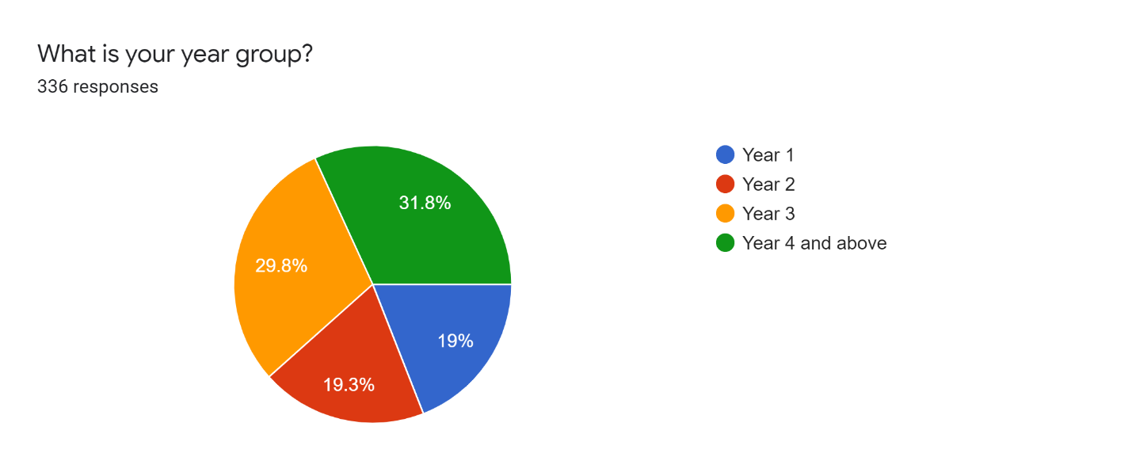

### Figure 1: Pie Chart showing the percentage of the different year groups among students

Figure 1 shows that the sample size included a majority of Year 4 and above students.

The respondents were asked what school and programme they belong to. Based on the total amount of respondents to this questionnaire,

* 15.5% were found to be from SCIT – Computer Science
* 8.9% were found to be from SCIT – Enterprise Systems
* 10.1% SCIT – Information Systems
* 9.2% SCIT – Networking
* 5.4% SCIT – Animation Production and Development
* 6.3% SCIT – Multimedia
* 8.3% FOE – Civil Engineering
* 6.3% FOE – Chemical Engineering
* 4.8% FOE – Electrical Engineering (Instrumentation)
* 6% FOE – Electrical Engineering (Power)
* 6% FOE – Electrical Engineering (Communication)
* 5.1% FOE – Electrical Engineering (Computing)
* 3.6% FOE – Industrial Engineering
* 4.8% FOE – Mechanical Engineering

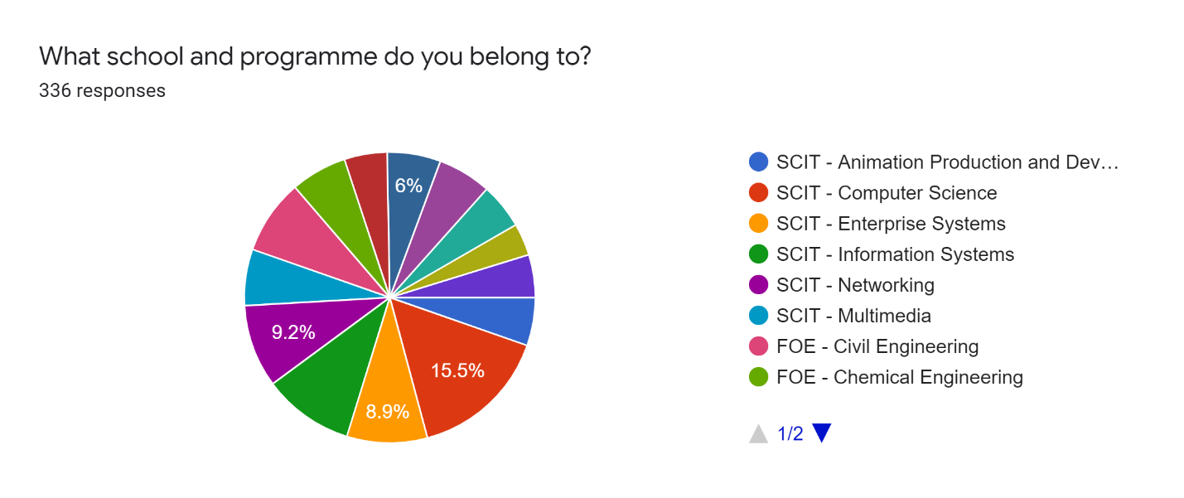

### Figure 2: Pie Chart showing the percentage of school and programme the students belong to

Figure 2 shows that the sample size included a majority of students from SCIT – Computer Science.

The respondents were asked if they ever met with their academic advisor. Based on the total number of respondents to this questionnaire, 83% were found to meet their academic advisor and the other 17% haven’t met their academic advisor (see figure 3 below).

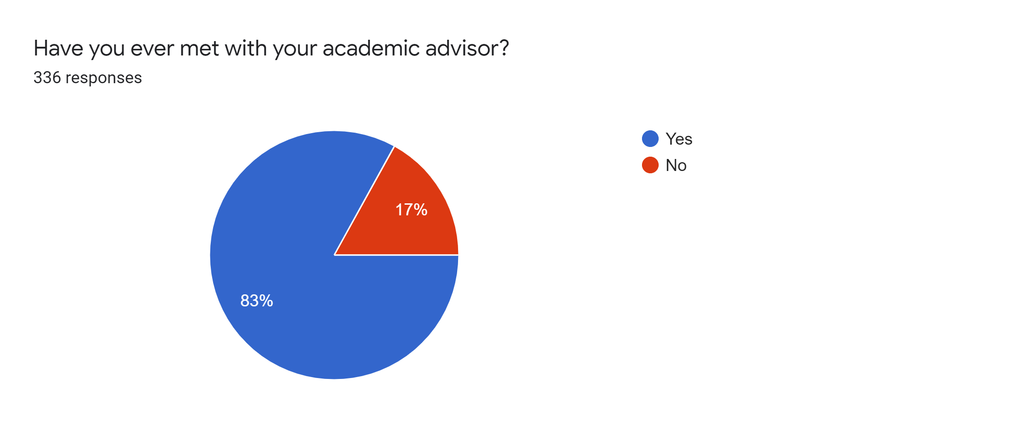

### Figure 3: Pie Chart showing the percentage of students who met or haven’t met their academic advisor

The respondents were required to state the reasons why they primarily seek advice from their advisor. The respondents were able to select all that apply and also another template to specify otherwise. Within the total respondents,

* 35.8% selected issue with grades
* 29.4% selected personal challenges
* 41.9% selected to explain rules or procedures
* 47.3% selected course selections
* 22.6% selected financial challenges

The other selections were chosen otherwise as shown in figure 4 below. From this particular question, 1 response was listed in the “If other, Please Specify” template. This respondent stated that the academic advisor has to sign the module withdrawal form.

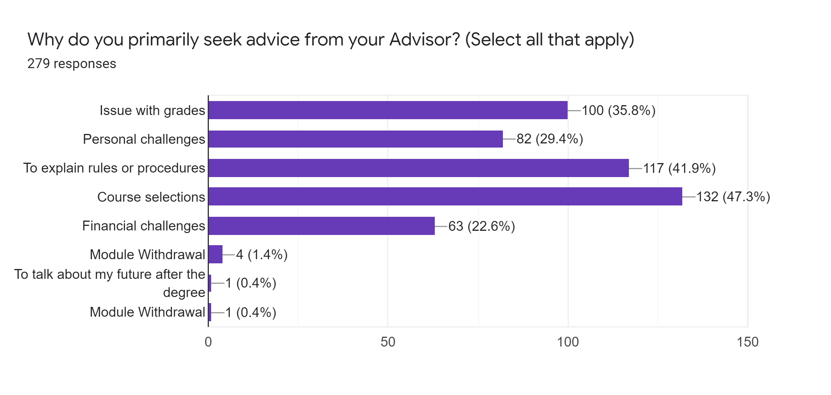

### Figure 4: Bar Graph showing the reasons why students primarily seek advice from their advisor

Figure 4 shows that the majority of the students had chosen course selections as why they primarily seek advice from their advisor.

The respondents who met their advisors were asked if their issues were resolved after meeting with their advisor. Based on the options given, 48.7% of the respondents selected “ Sometimes”, 47% of the respondents selected “Yes”, 2.9% of the respondents selected “No” and 1.4% selected “Not Applicable” as shown in figure 5 below.

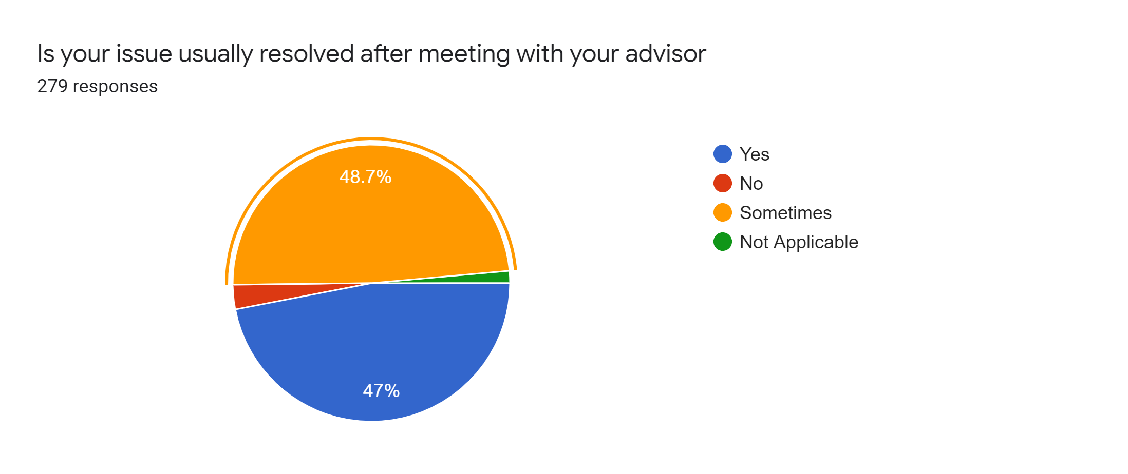

### Figure 5: Pie Chart showing if students issue was resolved after meeting with their advisor

Figure 5 shows that the majority of the students' issues were resolved sometimes.

The respondents who met with their advisor were asked how often they have contact with their advisor. Based on the options given,

* 49.6% were found to have contact with their advisor 2-3 times each semester
* 27.9% were found to have contact with their advisor during registration/once each semester
* 21.8% were found to have contact with their advisor 4 or more times each semester
* 0.8% were found to never have any contact with their advisor

These percentages are shown in figure 6 below.

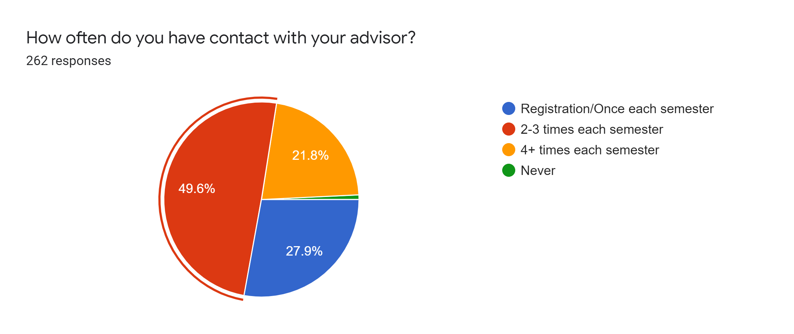

### Figure 6: Pie Chart showing the percentage of how often students have contact with their advisor

Figure 6 shows that the majority of students contacted their advisor 2-3 times each semester.

To further justify the need for the automated academic advisement system, the respondents who met with their advisor were asked to rate from 1 (lowest) to 5 (highest) how satisfied they are with the academic advising experience at UTech, JA. The Bar Graph below (figure 7) shows that:

* 25.4% of respondents rated 5/5
* 43.1% of respondents rated 4/5
* 21.5% of respondents rated 3/5
* 8.1% of respondents rated 2/5
* 1.9% of respondents rated 1/5

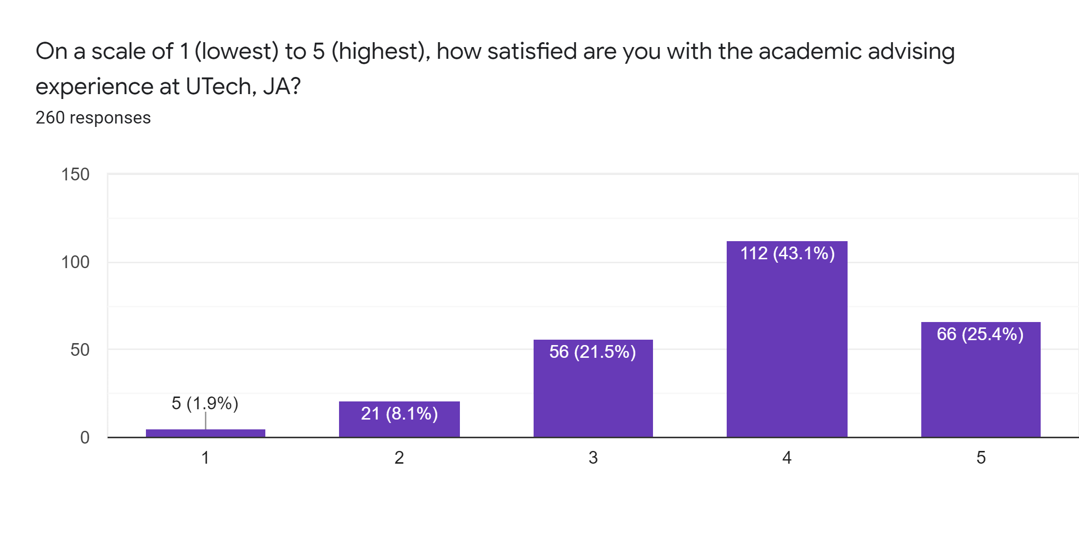

### Figure 7: Bar Graph showing on a scale from 1 (lowest) to 5 (highest) how students are satisfied with the academic advising experience at UTech, JA

Figure 7 shows that the majority of students rated the poll 4/5 on how satisfied they are with the academic advising experience at UTech, JA.

The respondents who met with their advisor were asked how quickly does their academic advisor respond to phone calls/emails. The Pie Chart below (figure 8) shows that:

* 35.9% of respondents selected “Within a week”
* 30.9% of respondents selected “Within 2-3 days”
* 24.8% of respondents selected “Within 24 hours”
* 8% of respondents selected “Not Applicable”

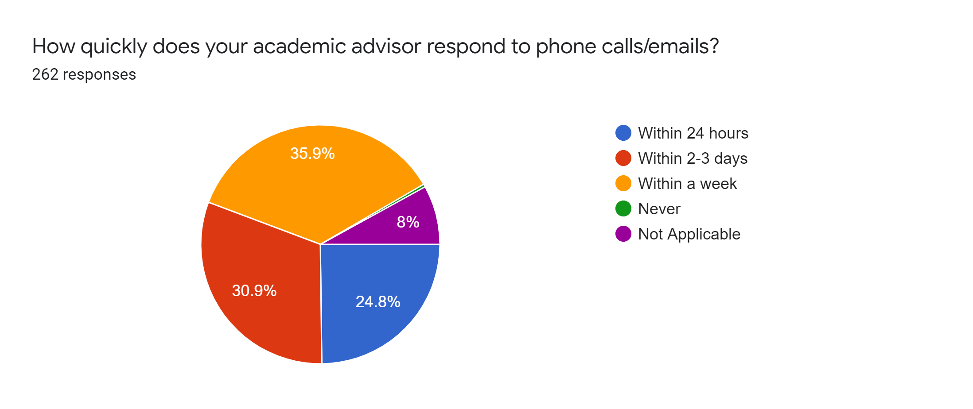

### Figure 8: Pie Chart showing the percentage of how quickly the students’ academic advisor respond to phone calls/emails

Figure 8 shows that a majority of students got a response from their academic advisor within a week via phone calls or emails.

The respondents were asked how they contact their advisor. The Pie Chart (figure 9) below shows that:

* 36.6% of respondents selected by email
* 28% of respondents selected by telephone
* 26.8% of respondents selected by appointment
* 8.6% of respondents selected none of the above

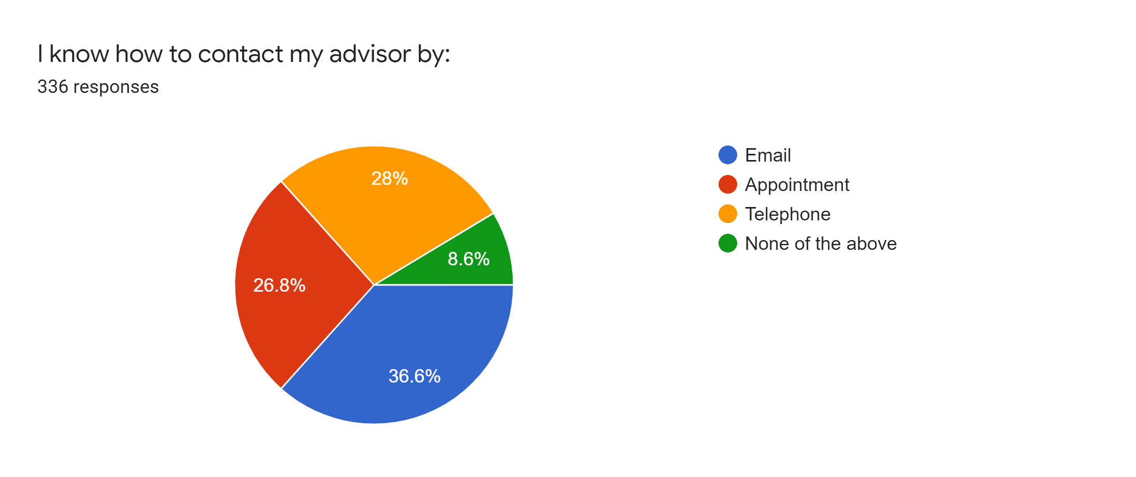

### Figure 9: Pie Chart showing the percentage of how students contact their advisor

Figure 9 shows that the majority of the students contact their advisors via email

The respondents were asked to rate on a scale of 1 (lowest) to 5 (highest) their understanding of academic policies and procedures. The Bar Graph below (figure 10) shows that:

* 20.2% of respondents rated poll 5/5
* 34.8% of respondents rated poll 4/5
* 22% of respondents rated poll 3/5
* 11% of respondents rated poll 2/5
* 4.2% of respondents rated poll 1/5

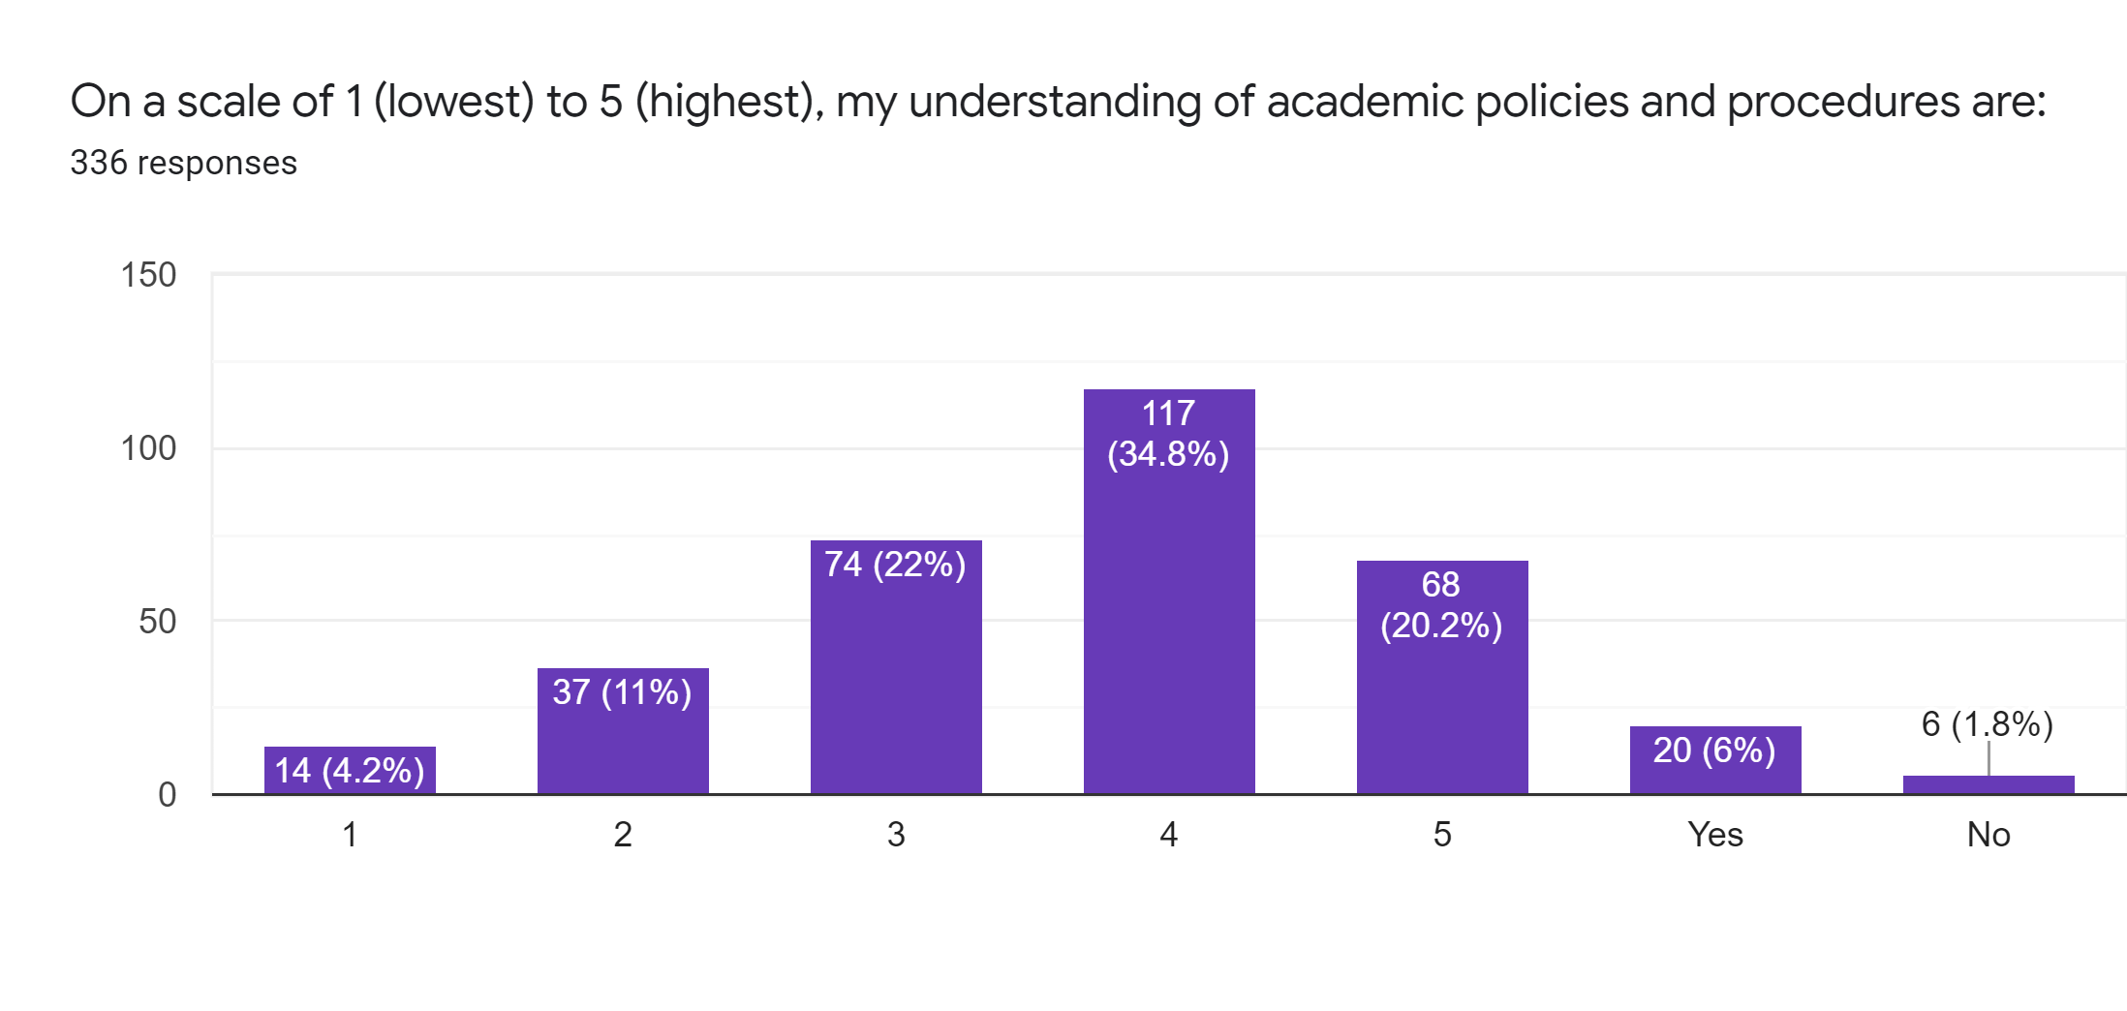

### Figure 10: Bar Graph showing on a scale from 1 (lowest) to 5 (highest) students understanding of academics policies and procedures

Figure 10 shows that the majority of students rated poll 4/5.

The respondents were asked to rate on a scale of 1 (lowest) to 5 (highest) their knowledge on how to access campus resources designed to support academic success. The Bar Graph (figure 11) shows that:

* 21.4% of respondents rated poll 5/5
* 24.4% of respondents rated poll 4/5
* 27.4% of respondents rated poll 3/5
* 15.5% of respondents rated poll 2/5
* 3.6% of respondents rated poll 1/5

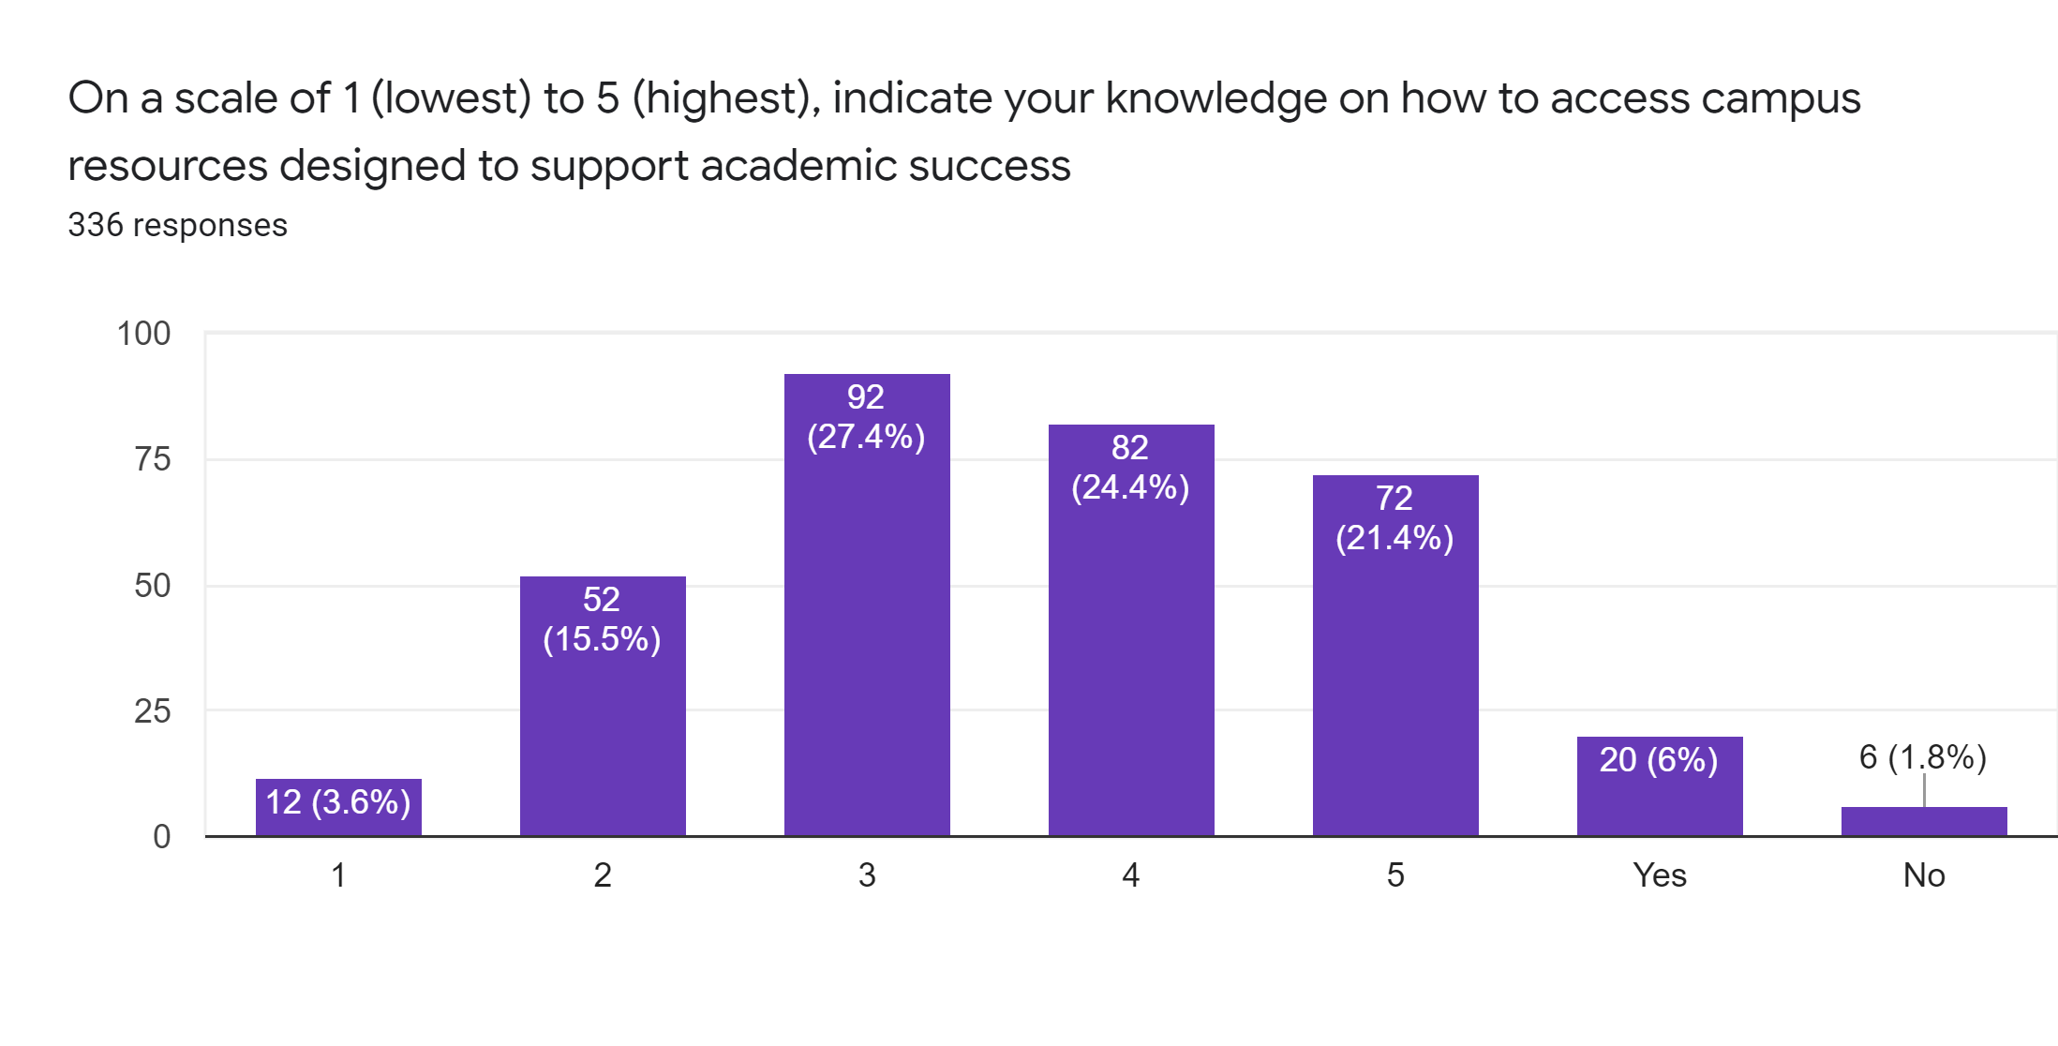

### Figure 11: Bar Graph showing on a scale of 1 (lowest) to 5 (highest) students’ knowledge on how to access campus resources designed to support academic success

Figure 11 shows that the majority of students rated poll 3/5.

The respondents were asked if they prefer a face to face or online session with their advisor. The Pie Chart (figure 12) shows that:

* 44.9% selected face to face
* 30.4% selected online
* 21.1% selected indifferent

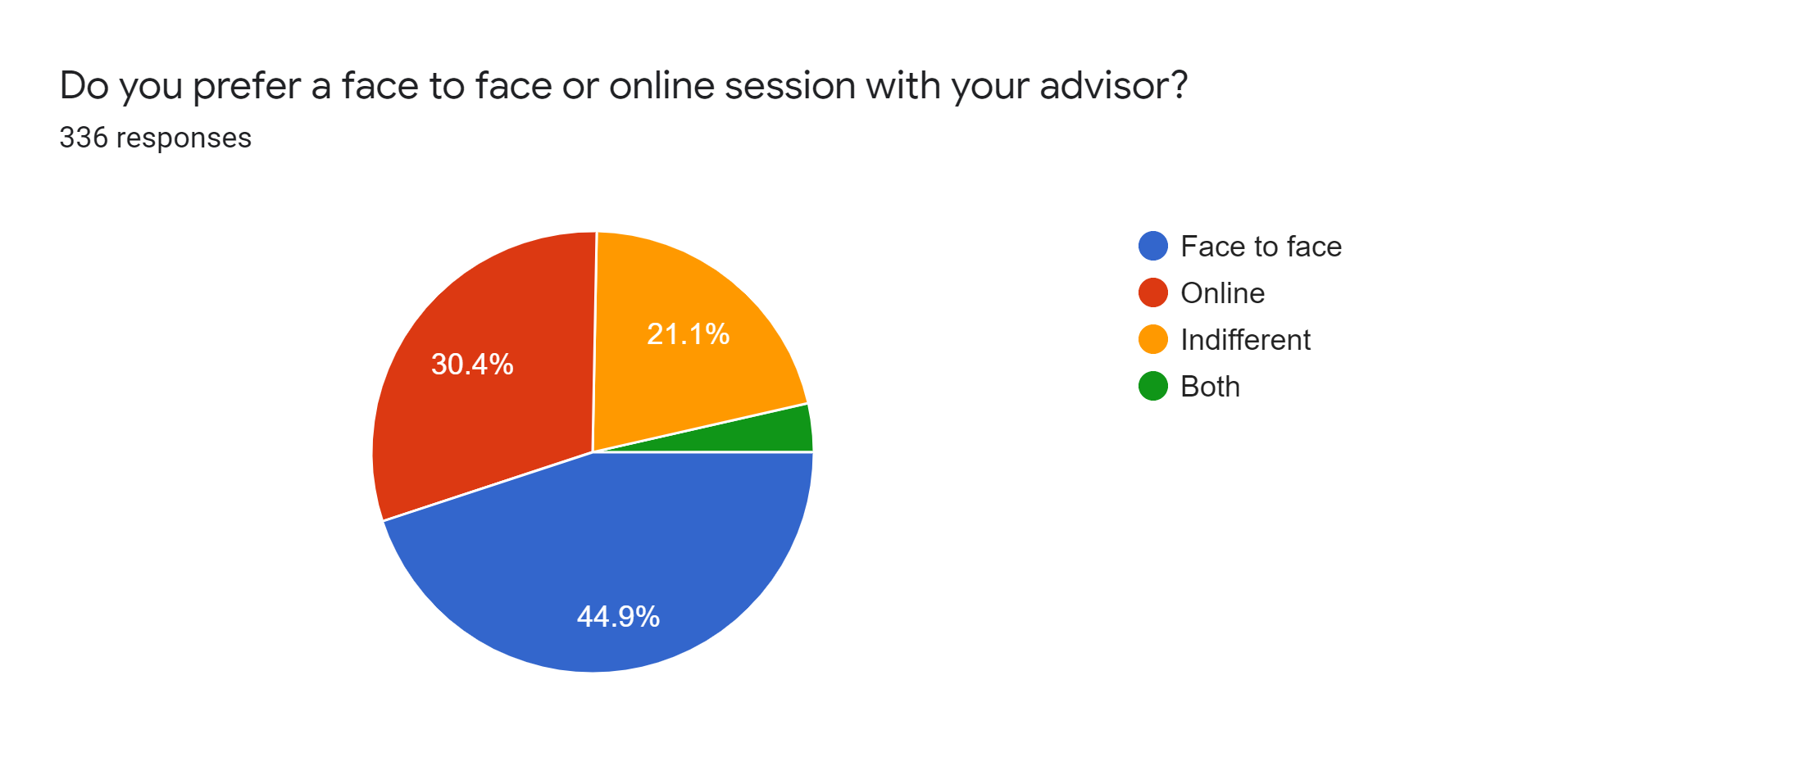

### Figure 12: Pie Chart showing if students prefer face to face or online session with their advisor

Figure 12 shows that the majority of students prefer face to face sessions with their advisor.

The respondents were asked what features they would like to see in a new advisement system. The Bar Graph (figure 13) shows that:

* 33% of respondents selected live chat feature
* 28.6% of respondents selected feedback tool
* 29.2% of respondents selected the option to switch advisors
* 37.8% of respondents selected view timetable
* 41.4% of respondents selected progress report
* 41.7% of respondents selected forms (grade forgiveness, module withdrawal, etc)
* 38.7% of respondents selected appointment tracker
* 27.4% of respondents selected whatsapp
* The other template showed specified responses such as Module Withdrawal 2.4% and Application forms 1.8%

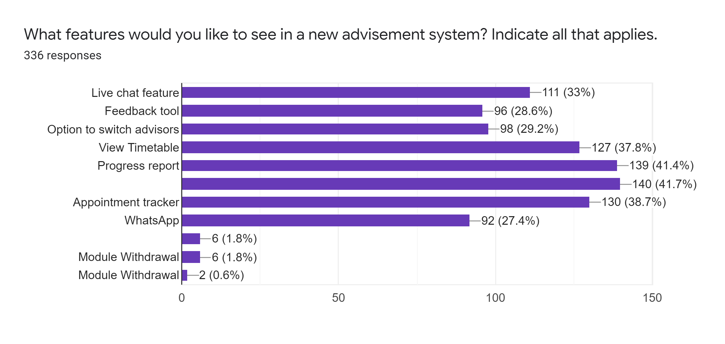

### Figure 13: Bar Graph showing what features students would like to see in a new advisement system

The respondents were asked to rate on a scale of 1 (lowest) to 5 (highest) how relevant is student advisement. The Bar Graph (figure 14) below shows that:

* 54.8% of respondents rated poll 5/5
* 19.6%% of respondents rated poll 4/5
* 11.3% of respondents rated poll 3/5
* 5.4% of respondents rated poll 2/5
* 1.2% of respondents rated poll 1/5

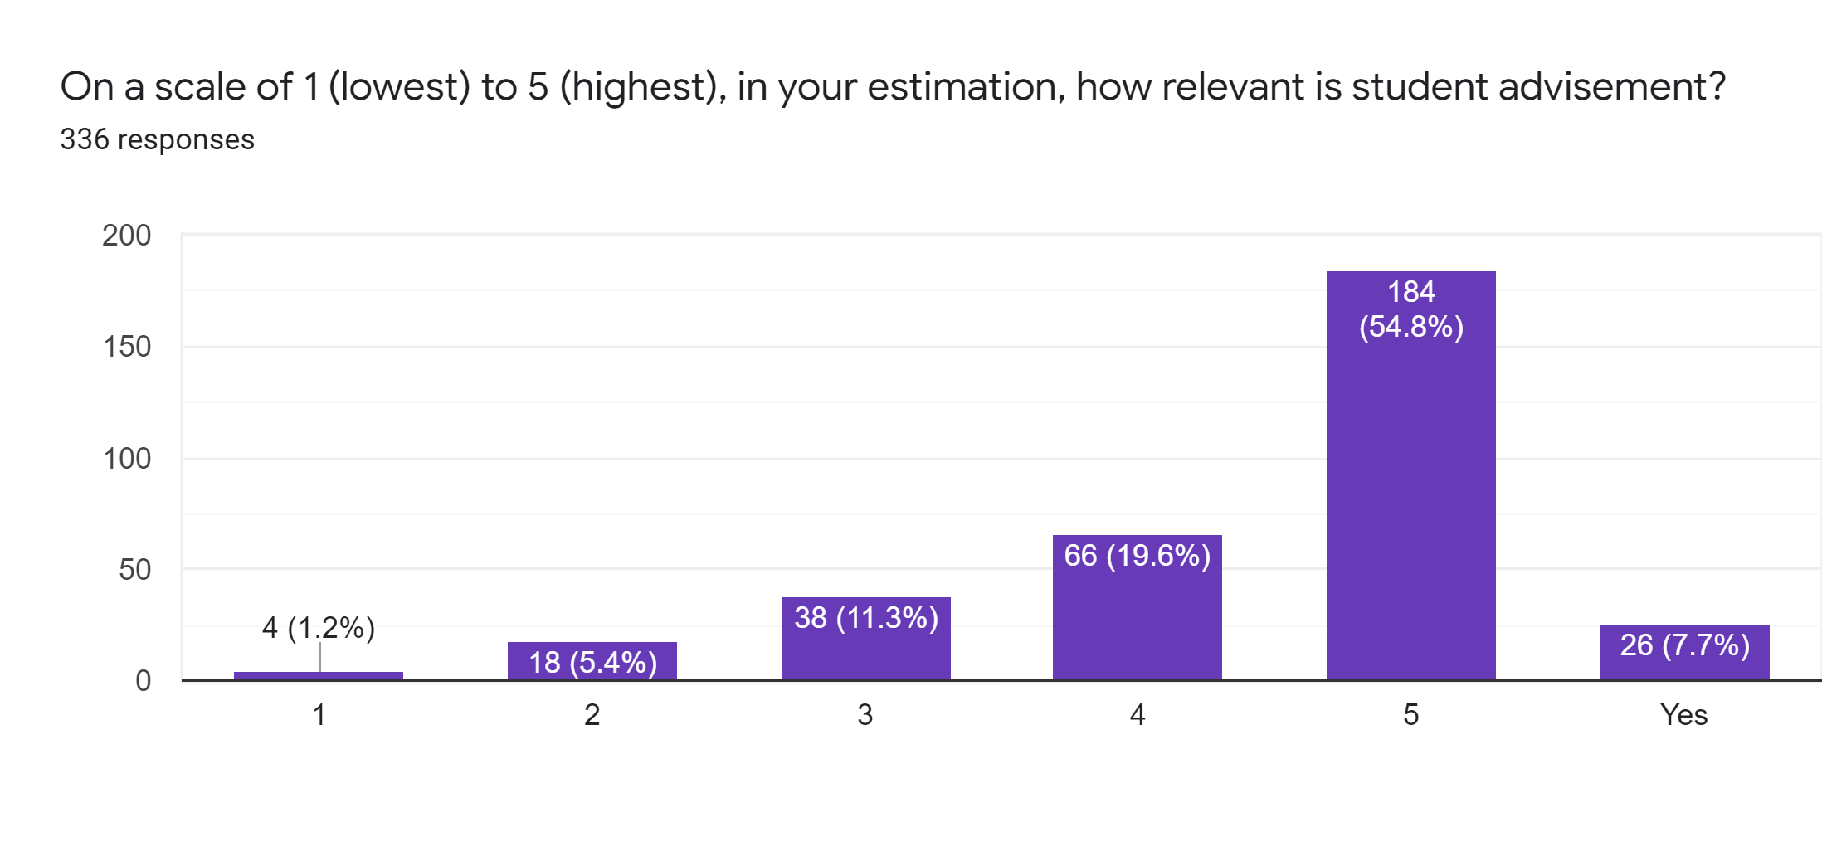

### Figure 14: Bar Graph showing how students rate on a scale of 1 (lowest) to 5 (highest) how relevant is student advisement

Figure 14 shows that the majority of students rated the poll 5/5 on how relevant is student advisement.

## Findings: Advisor Respondents

The respondents were asked how many years of experience as an advisor they have. The Pie Chart (figure 15) below:

* 24.2% of respondents selected 1 year
* 9.1% of respondents selected 2 years
* 9.1% of respondents selected 3 years
* 12.1% of respondents selected 4 years
* 45.5% of respondents selected 5 years and over

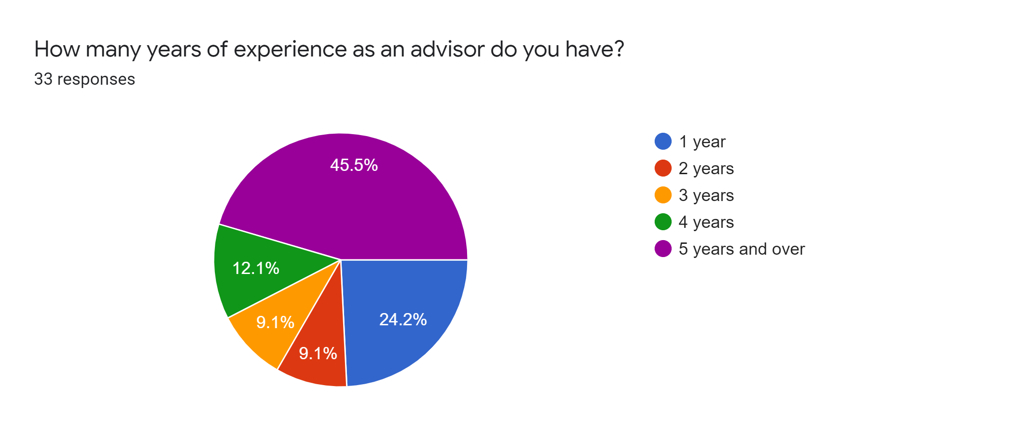

### Figure 15: Pie Chart showing how many years of experience do the advisors have

Figure 15 shows that the majority of these advisors have 5 years and over of experience in student advisement.

The respondents were asked on average how many students do they assist weekly. The Pie Chart (figure 16) below shows that:

* 3% of respondents selected 0
* 30.3% of respondents selected 1-4
* 21.2% of respondents selected 5-10
* 30.3% of respondents selected 11-20
* 15.2% of respondents selected over 20

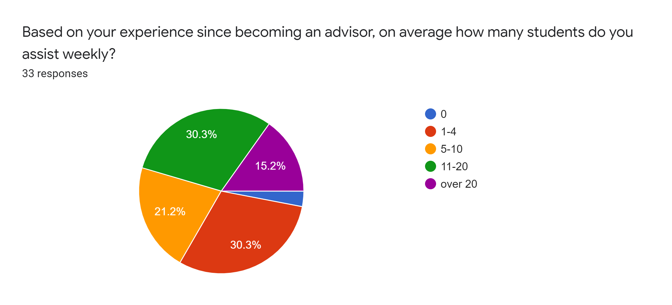

### Figure 16: Pie Chart on average how many students do these advisors assist weekly

Figure 16 shows that the majority of the advisors on average assisted 1-4 students weekly

The respondents were asked how long does it generally take to resolve a student’s query. The Pie Chart (figure 17) shows that:

* 21.1% of respondents selected 1-14 minutes
* 27.3% of respondents selected 15-30 minutes
* 15.2% of respondents selected less than a day
* 12.1% of respondents selected 1-2 days
* 24.2% of respondents selected 1 week

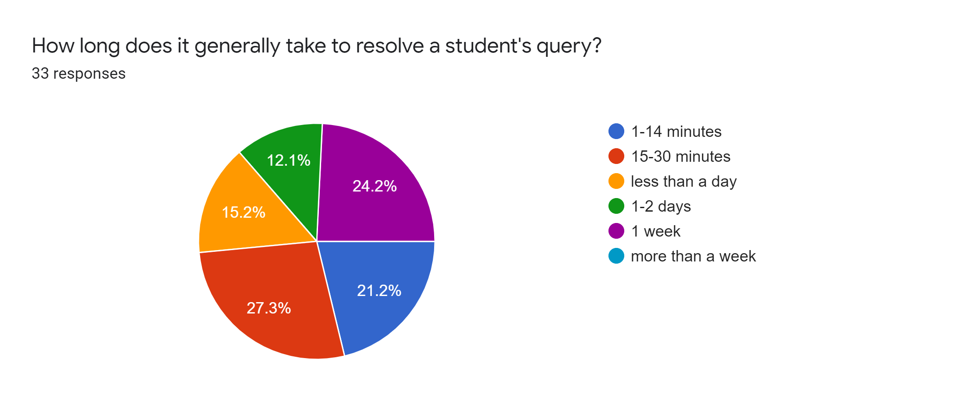

### Figure 17: Pie Chart showing the percentage of how long does it generally took for advisors to resolve a student’s query

Figure 17 shows that the majority of the respondents took 15-30 minutes to resolve a student’s query.

The respondents were asked how difficult it is to maintain contact with each student to notify them of the status of the query/task. The Bar Graph (figure 18) below on a scale of 1 (easiest) to 10 (hardest) shows that:

* 9.1% of respondents selected 1/10
* 12.1% of respondents selected 2/10
* 6.1% of respondents selected 3/10
* 9.1% of respondents selected 4/10
* 9.1% of respondents selected 5/10
* 12.1% of respondents selected 6/10
* 27.3% of respondents selected 7/10
* 15.2% of respondents selected 8/10
* No respondents selected 9/10
* No respondents selected 10/10

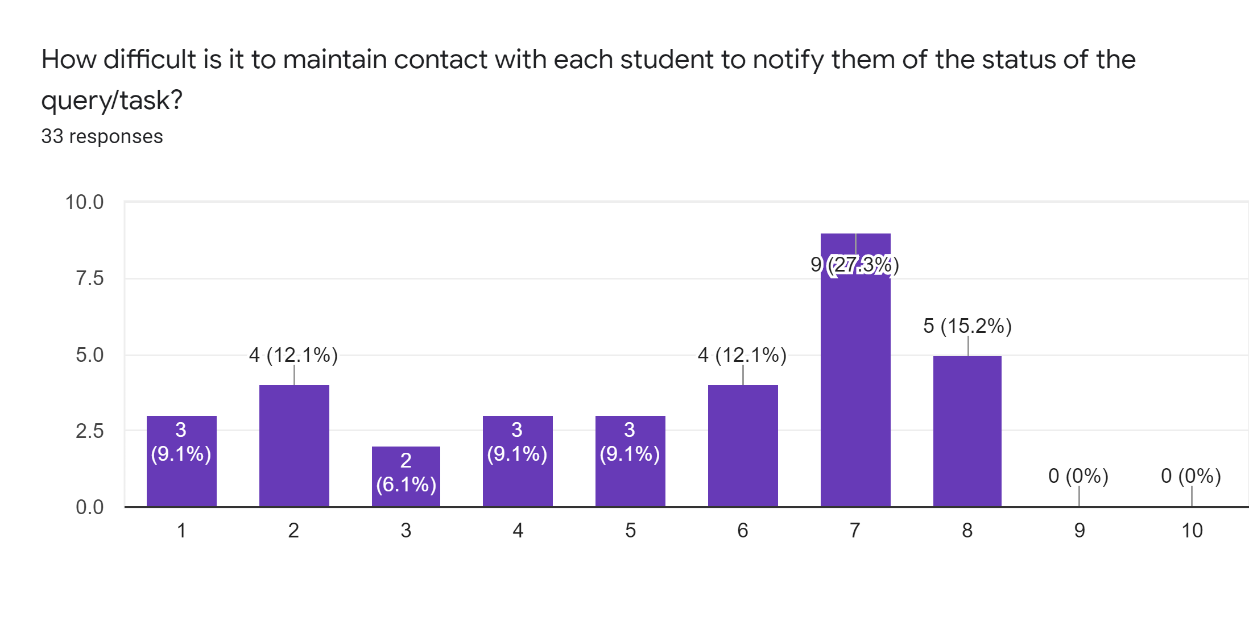

**Figure 18: Bar Graph showing on a scale of 1 (easiest) to 10 (hardest) how difficult it is for advisors to maintain contact with each student to notify them of the status of the query/task**

Figure 18 shows that the majority of advisors selected 7/10 on how difficult it is for them to maintain contact with each student to notify them of the query/task.

The respondents were asked on a scale of 1 (lowest) to 10 (highest) how efficient is the process of handling student queries/tasks. The Bar Graph (figure 19) shows that:

* 15.2% of respondents selected 1/10
* 6.1% of respondents selected 2/10
* 9.1% of respondents selected 3/10
* 12.1% of respondents selected 4/10
* 12.1% of respondents selected 5/10
* 15.2% of respondents selected 6/10
* 21.2% of respondents selected 7/10
* 6.1% of respondents selected 8/10
* No respondents selected 9/10
* 3% of respondents selected 10/10

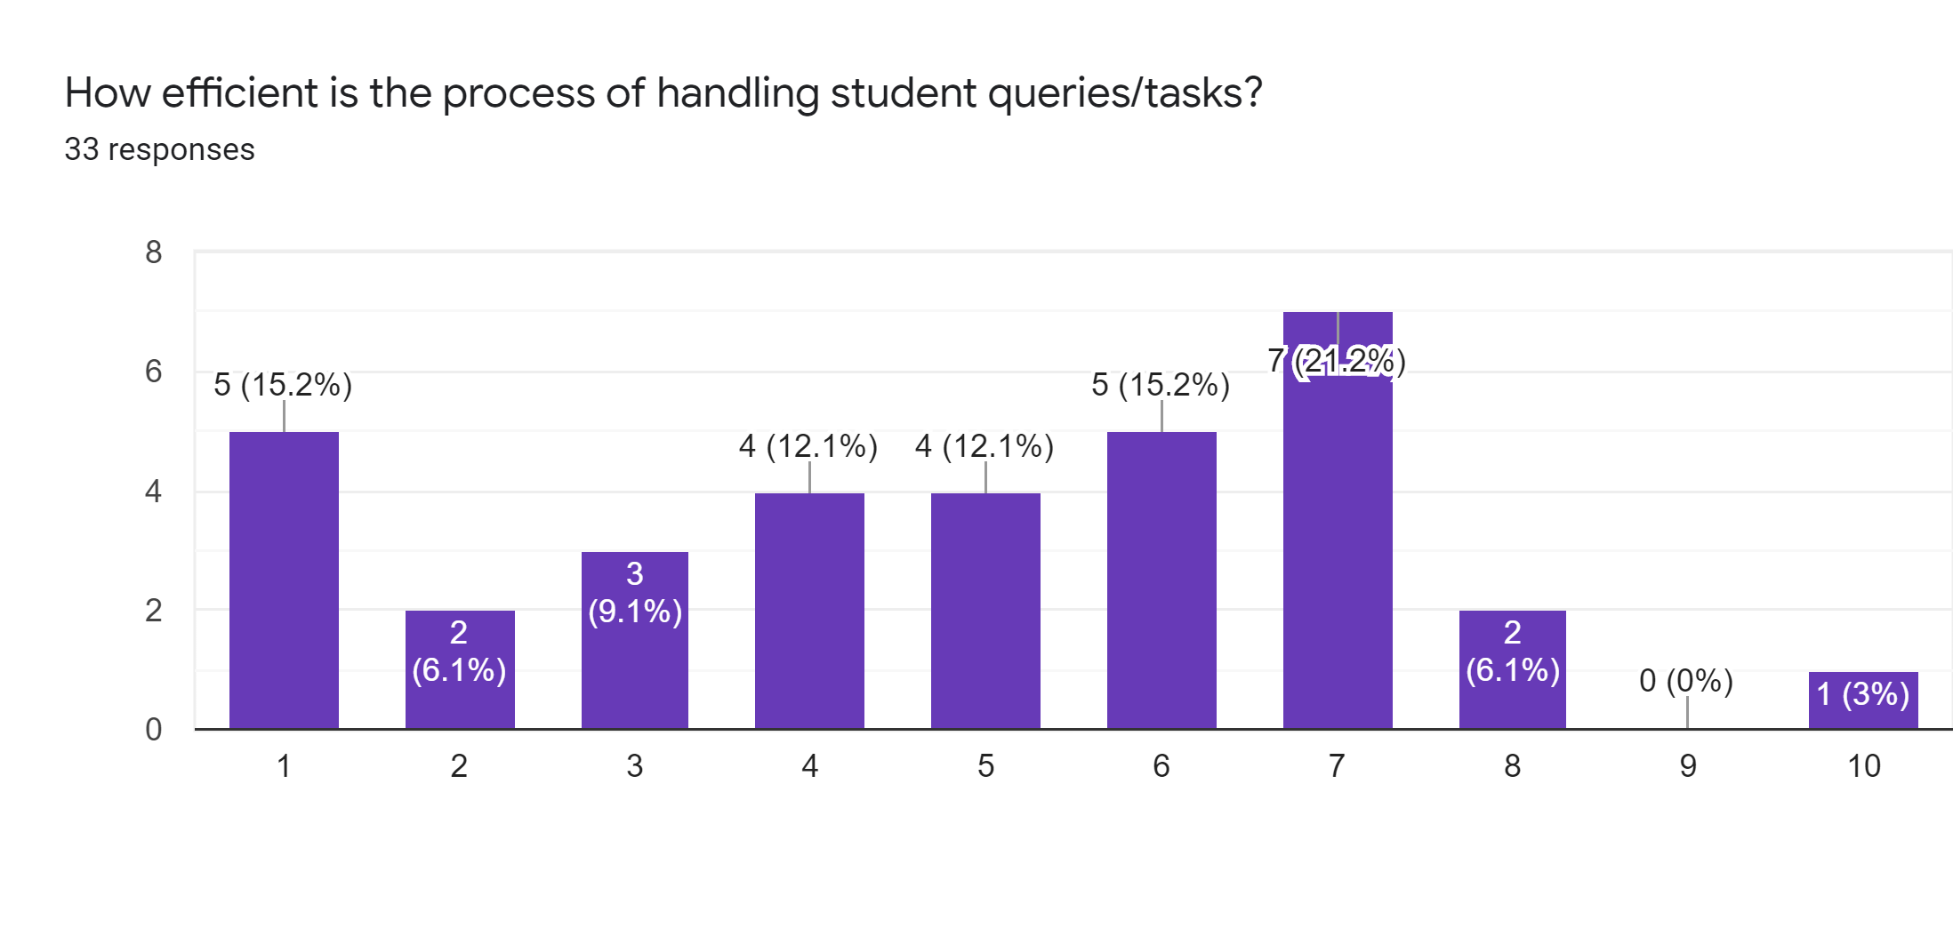

### Figure 19: Bar Graph showing on a scale of 1 (lowest) to 10 (highest) how efficient is the process of handling student queries/tasks

Figure 19 shows that the majority of advisors selected 7/10 on how efficient the process is of handling student queries/tasks.

The respondents were asked to describe the volume of paper used within their department. In summary, the responses were:

* A Lot of papers
* The process is too manual as such too much papers

These responses show that a lot of papers are being used in the current academic advisement system.

The respondents were asked if there is a need to share tasks between administrative representatives. The Pie Chart (figure 20) shows that:

* 87.9% of respondents selected Yes
* 12.1% of respondents selected No

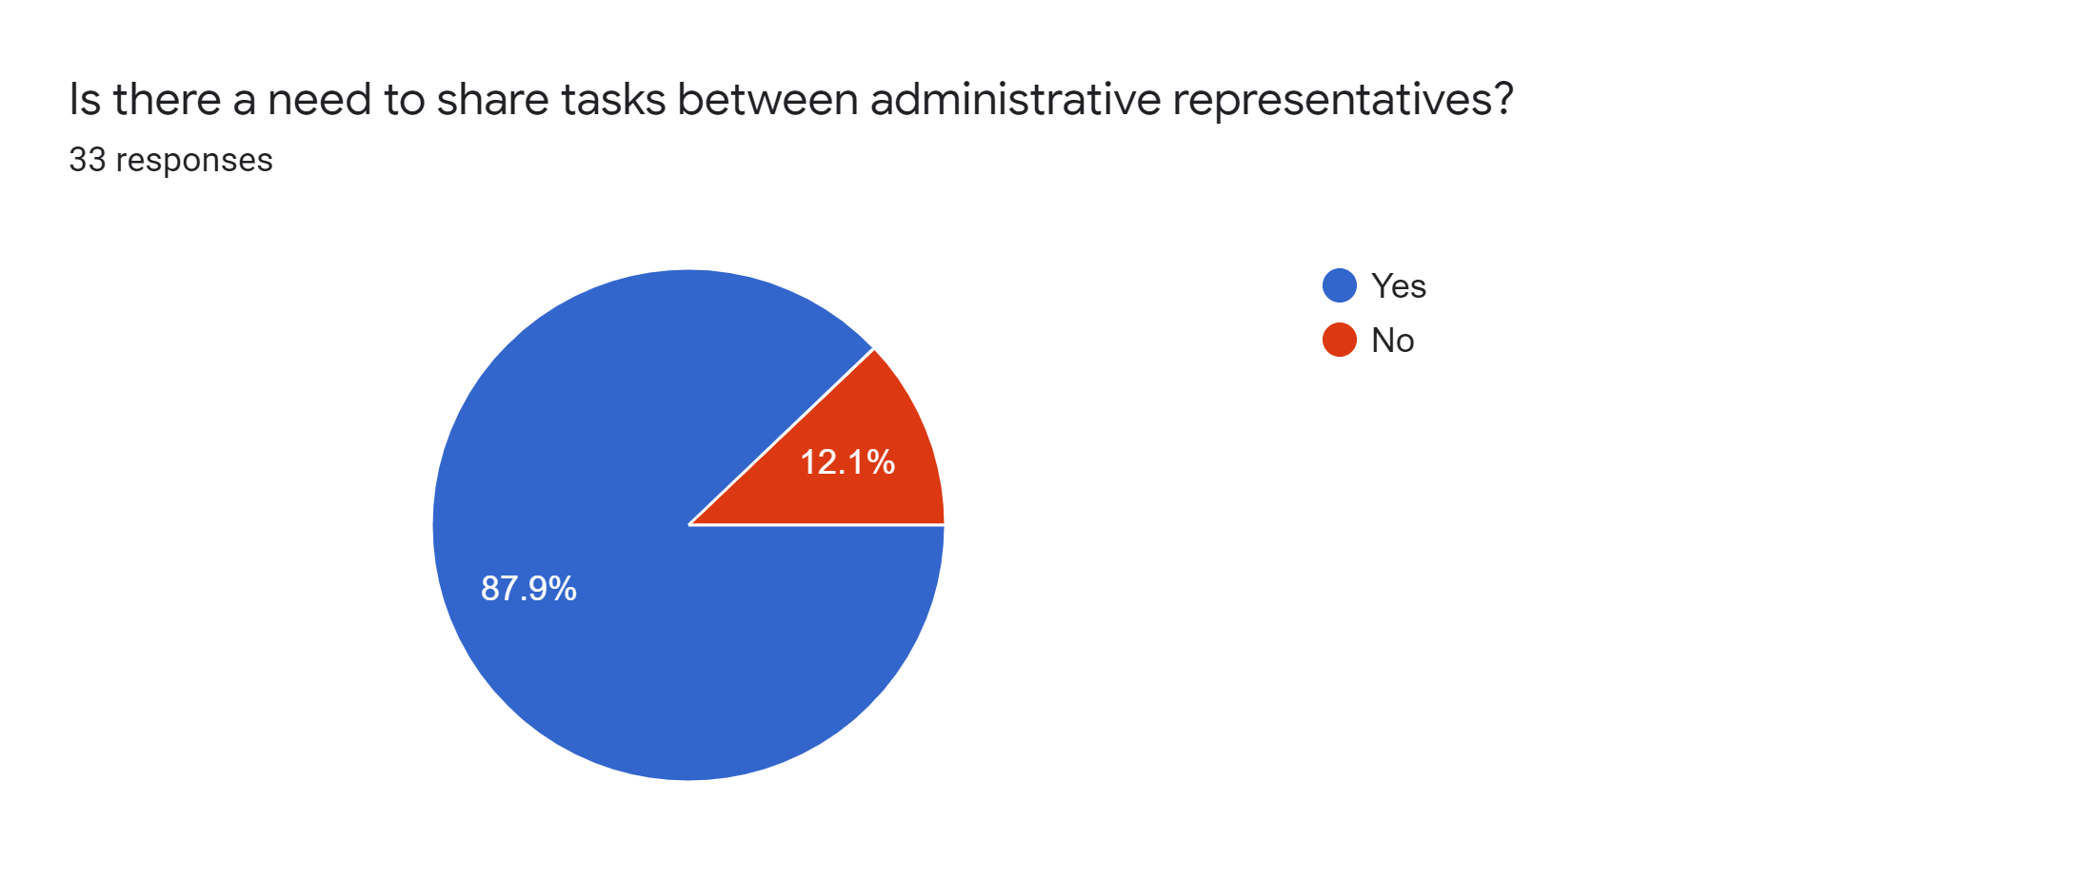

### Figure 20: Pie Chart showing if there is a need to share tasks between administrative representatives

Figure 20 shows that the majority of advisors see a need to share tasks between administrative representatives.

The respondents were asked what are some tasks that need to be shared between administrative representatives. In summary, the responses were:

* Update/Changes of records
* Miscellaneous
* Organize relevant forms
* Contact students and/or submit the document to another department
* Handle the paper volume
* Relay necessary information to different departments
* Results of advisement session. If any take resulted in administrative changes
* Gathering the forms, keeping a record, reviewing the forms to see how student advisement could be improved
* Transfer request and document retrieval
* Looking for grades

The respondents were asked if automating the above tasks would assist the student advisement process. The Pie Chart (figure 21) below shows that:

* 100% of respondents selected Yes
* No respondent selected No

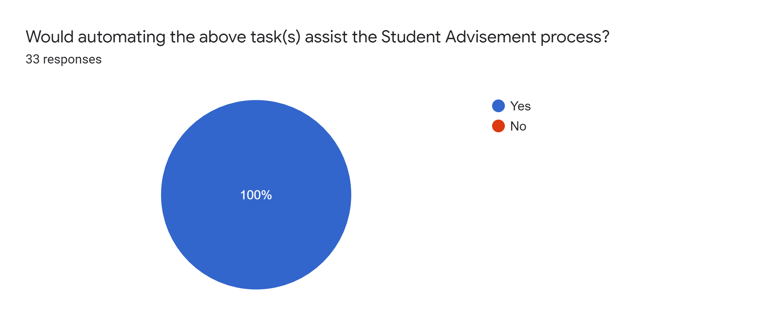

### Figure 21: Pie Chart showing advisors preference if automating the above tasks would assist the student advisement process

Figure 21 shows that all advisors preferred to automate the above tasks to assist the student advisement process.

The respondents were asked what are the forms required for use by each administrative representative in student advisement. In summary, the responses were:

* Student Advisement Record
* Advisor Record
* Change of advisor record
* Miscellaneous Forms
* Folder of forms for each advisor
* Grade release and Current matriculation form
* Student concern forms
* Forms that gather the outcome of student advisement
* Forms that determine how best to advise students in a given situation
* Registration forms
* Checklist for the advisement process
* Forms that govern the advisement process

The respondents were asked on a scale of 1 (lowest) to 10 (highest) how convenient the present system is to update administrative information and notify other admin representatives of student advisement issues. Bar Graph (figure 22) below shows that:

* No respondent selected 10/10
* 3% of respondents selected 9/10
* No respondent selected 8/10
* 18.2% of respondents selected 7/10
* 15.2% of respondents selected 6/10
* 24.2% of respondents selected 5/10
* 12.1% of respondents selected 4/10
* 21.2% of respondents selected 3/10
* 6.1% of respondents selected 2/10
* No respondent selected 1/10

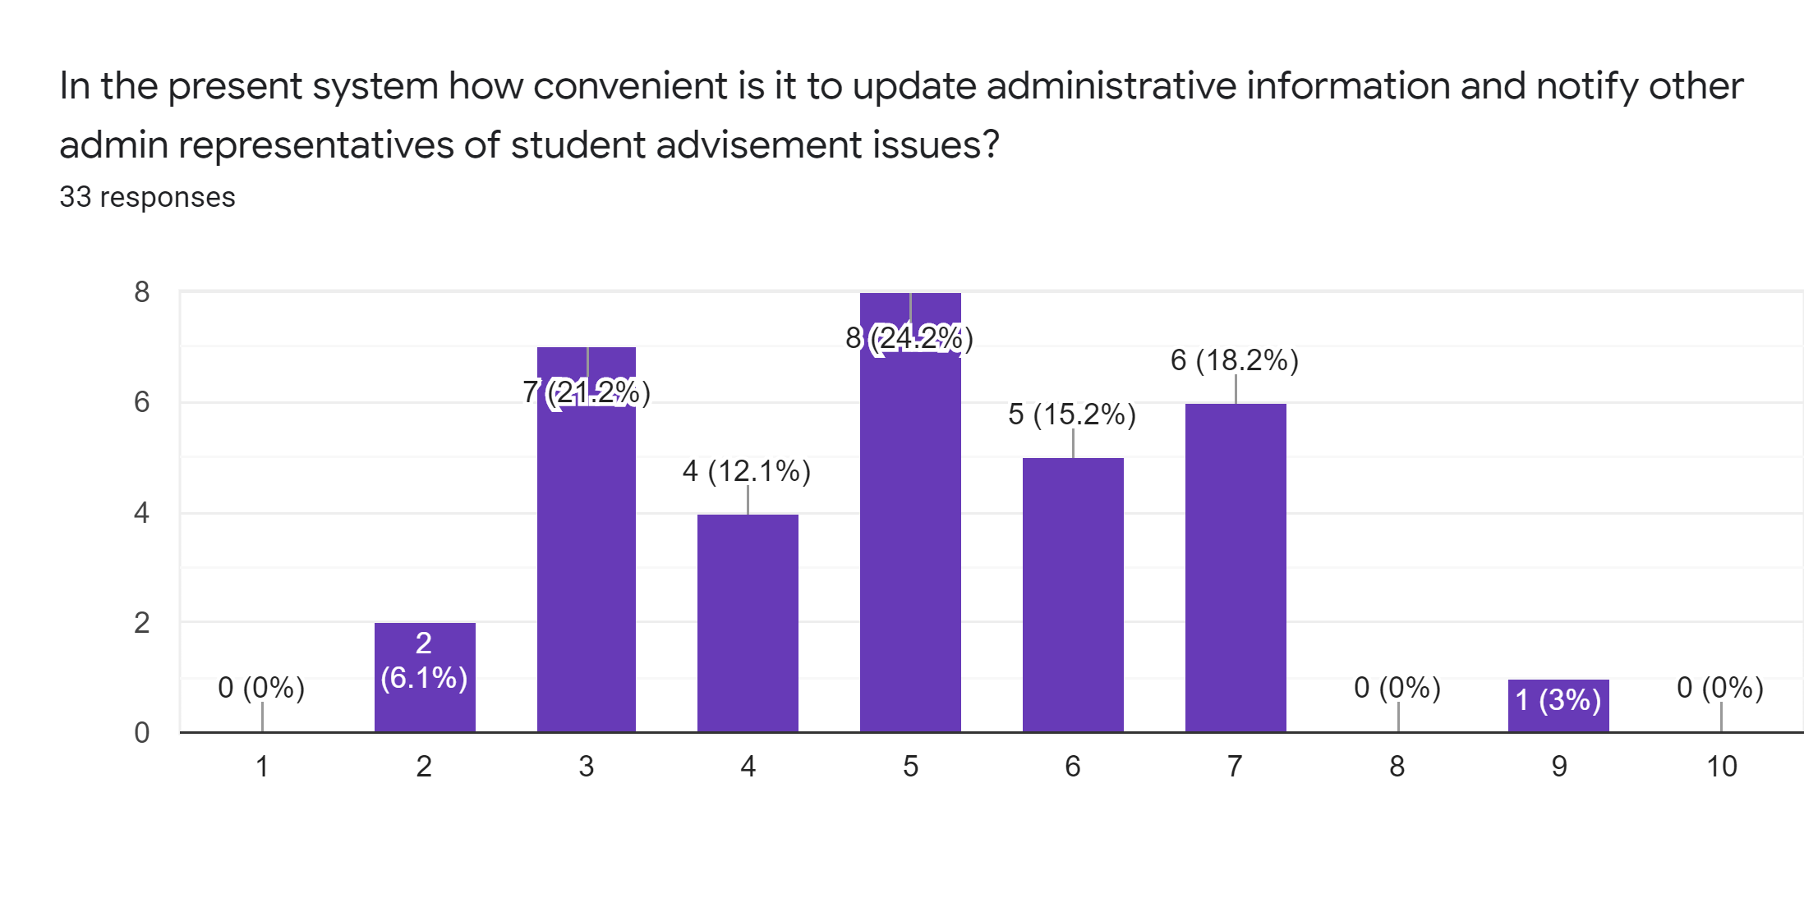

### Figure 22: Bar Graph showing on a scale of 1 (lowest) to 10 (highest) how convenient is the present system to update administrative information and notify other admin representatives of student advisement issues

Figure 22 shows that the majority of advisors selected 5/10 on how convenient the present system is to update administrative information and notify other admin representatives of student advisement issues.

## Findings: Administrator Respondents

Four interviews were conducted from administrators and several questions were answered which may justify the implementation of an automated student advisement system with suitable features.

Some of the questions were captured with their responses to highlight the administrator’s feedback about an automated student advisement system for the Faculty of Engineering and Computing at the University of Technology, Jamaica.

Questions and Responses

1. What are the criteria that determine the assignment of students to advisors when they begin their course of study? Students are assigned to particular lecturers who are academic advisors on a random basis once the student is an active member of the school and the lecturer is an active member of staff. Assignment of students is done by the administrative staff, most likely manually.
2. What are some of the factors that call for an improvement of the student advisement process in the Faculty of Engineering and Computing? The system could be improved where students can be assigned to only active members of staff. Students could be allowed to get in contact with their advisors easier provided that the advisor is willing to disclose certain information such as emails or contact numbers.
3. What are the factors that could lead to the reassignment of a student to an advisor?
   1. Retirement of a student advisor
   2. Resignation of a student advisor
   3. A request submitted by the student to change their advisor
4. Do you believe an improved system with the help of automated responses can increase student retention? Yes, an automated response system could ease the tension with a student seeking advice in cases where they may feel uncomfortable.
5. How do you believe an automated system will improve student retention? An automated system that facilitates easier communication could help improve student retention because it would allow for more interaction between advisors and advisees (students) instead of students seeking certain advice from their peers.
6. Do you believe an improved system could foster a relationship where students feel more comfortable to seek advice? Yes, a more interactive and student-focused system will improve communication that could allow students to feel more comfortable and reduce the fear attached to seeking help from authoritative figures such as student advisors university-wide.
7. What are some ways you believe an improved system can help to foster the student-advisor relationship? The system could foster these relationships by making student advisement more appealing to all the personnel involved, specifically the student and the advisor. This can be achieved by trying to improve the human aspect of student advisement such as lecturers being unwilling to take on a certain number of students or unwillingness to help students based on other factors. Students should also be willing to communicate in a certain manner with their advisors.
8. What are some features you believe an improved system could include that could make the student advisement process more conducive to students and advisors? Features that allow for better communication, whether via email or chat etc. If more students and advisors can interact then the student advisement process can be improved and streamlined.
9. Do you have any challenges with students’ issues when assisting them in resolving the situation? Yes, of course, There was a situation with a student where his issue was very personal. The student had to seek counselling from the school counselling department. At that point the matter required special handling that was outside of the advisor’s scope.

## Answers to Research Questions

Question 1: What are some of the features that advisors and advisees would like to see in an automated Academic Advisement System?

Based on the findings, the features the users would like to see in an automated Academic Advisement System are:

* Messaging System
* Scheduling System
* Digital Forms
* Progress Report
* Live Chat
* Switch Advisor

Question 2: What are some student concerns that cannot be resolved through academic advisement?

Based on the findings, some students’ concerns require special handling that are outside of the advisor’s scope. For example, in a case where a student needs counselling, an advisor may not be fit to carry out this duty so the student would need to be referred to the counselling unit of the university to be properly assisted.

## Conclusion

These findings help to determine the need for an automated student advisement system with suitable features. With this said, advisors, advisees and administrators’ concerns can be resolved seamlessly through this implementation. With this automated system, advisees can be satisfied with how their issues or queries are being addressed by the advisors and at the same time accommodating these advisors to better assist advisees. This system will gear towards allowing administrative representatives to deal with both advisors and advisees issues while being a support to persons using the system to assist in maintaining streamlined processes in a very efficient manner. Students will be able to have their queries and tasks being effectively followed-up and addressed by the administrators.

# 

# 

# **Chapter 5**

# **Summary, Conclusions and Recommendations**

## Summary

The current academic advisement system within the Faculty of Engineering and Computing at UTECH was reviewed and data was gathered from advisors, advisees and administrators to highlight the preferred features for an automated version of the system.

Some of the preferred features identified for a potential automated academic advisement system were:

* Advisors and advisees being able to communicate and collaborate efficiently using a messaging system, which advisees can either schedule an appointment face-to-face or online.
* Better records of advisees’ queries and advisors’ recommendations that solved students’ queries, which can be useful for future advisement.
* Seamless accessibility of university resources all in one place where students and advisors can retrieve easily.
* Proper storage of information to reduce data redundancy and ensure data integrity.
* Allow the administrators to communicate with advisors and advisees, continually updating necessary records and to complete their administrative tasks efficiently and effectively.

The research team came up with an automated academic advisement system which advisors, advisees and administrators within the Faculty of Engineering and Computing would be able to use. To facilitate this automated academic advisement system the team must comply with the following procedures:

* Meetings held to decide the requirements and scope of the system.
* The proposal is written and presented to be approved by our supervisor.
* Update meetings were held throughout the project execution to discuss current progress and the future steps to be taken.
* With the supervisor’s approval, discussions were conducted based on the problem or need for the project.

From this, the following research questions were developed:

1. What are some of the features that advisors and advisees would like to see in an automated Academic Advisement System?
2. What are some student concerns that cannot be resolved through academic advisement?

The objectives derived by the team members to aid in the proper execution of the project were:

1. Allow efficient communication and collaboration between advisors and advisees.
2. To have information such as students’ queries, advisors’ recommendations and university resources being stored in a centralized area that can be useful for future advisement while reducing data redundancy and ensuring data integrity.
3. To allow communication and tasks to be carried out efficiently by the administrators with the automated advisement system.

## Conclusion of Findings

From the analysis of the following shown in Chapter 4 (Findings), the following can be derived:

1. Though advisees are interested in a automated system and have highlighted many online features they would like to see in a new system, a large number still appreciate the face-to-face element of the current advisement system.
2. Advisors are able to resolve several student issues through academic advisement but some concerns have to be handled by specialized departments completely.
3. Administrators would benefit from the evolution from a paper-based system to an automated on to ensure easier record keeping.

## Conclusion of Project

The project was challenging to all the team members especially in the coronavirus pandemic which caused a delay in completing the project on time. The team had to collaborate over the internet using Zoom, Trello and WhatsApp instead of meeting face-to-face in completing this project, which hindered the application implementation of the project. At the end of the timeframe, the project was a success and the application was fully functional. The list below describes the conclusion of the project:

* The team collaborated well and implemented an automated Academic Advisement system with suitable features which could be beneficial to the Faculty of Engineering and Computing.
* The initial major project deadlines were not met but the team was able to complete the proposed system promptly for final viva.
* Due to the timeframe and coronavirus pandemic, the team decided to do a standard computerized system instead of a more advanced system such as an Intelligent Interactive Automated System or Intelligent Advanced Automated System.

## Recommendations

Once the project has been concluded there are several directions that this project could take. The following is a list of recommendations:

* The Faculty of Engineering and Computing at the University of Technology can consider using this automated Academic Advisement system for their advisement purposes.
* It is recommended that advisors and administrators are properly trained to use the system.
* The ongoing implementations of the automated Academic Advisement can broaden the usage of the system to other faculties within the University of Technology.
* Proper maintenance of the automated Academic Advisement system must be done on a daily or weekly basis.
* The automated Academic Advisement system can be upgraded to a more advanced system for the benefit of the Faculty of Engineering and Computing.
* Future enhancement of the system to a more advanced category.

# **Application Demonstration: Proposed Automated Academic Advisement System**



**Image 1: The landing page for the application.**

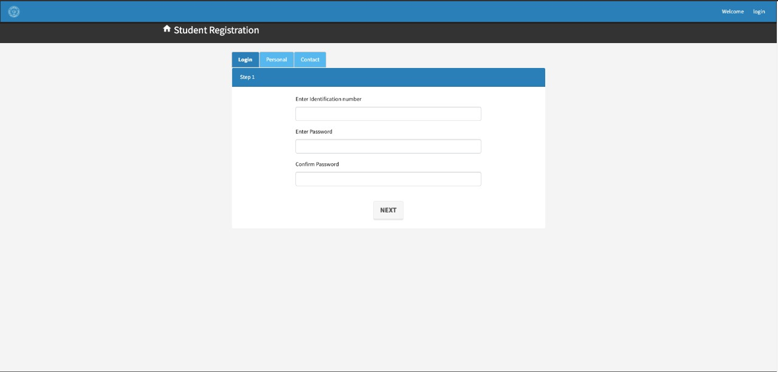

**Image 2: The student login page**

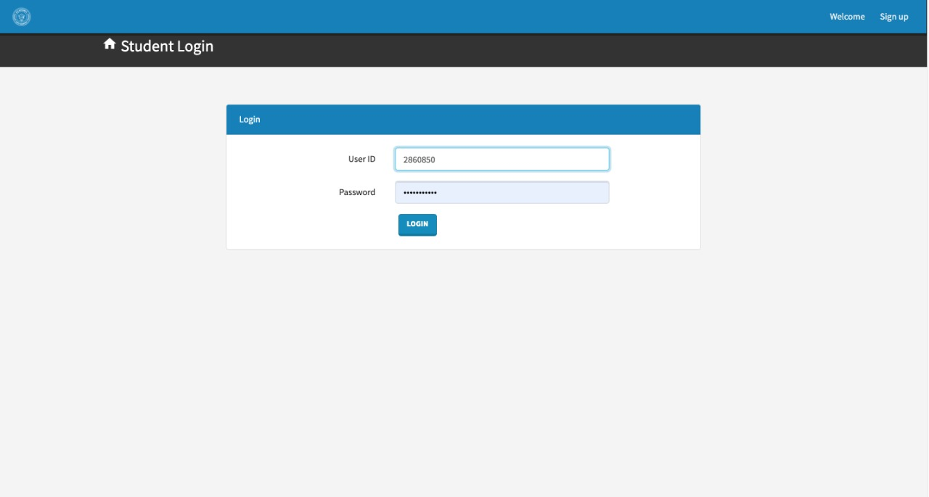

**Image 3: The student sign in page**

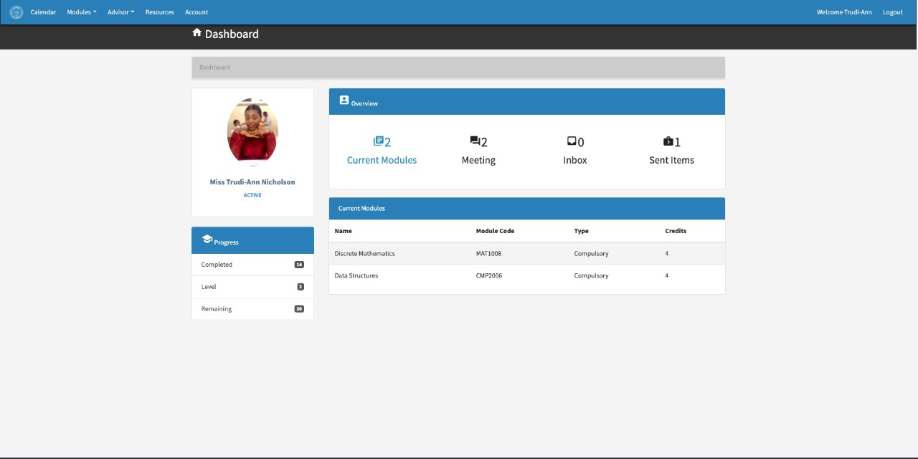

**Image 4: The student’s dashboard**

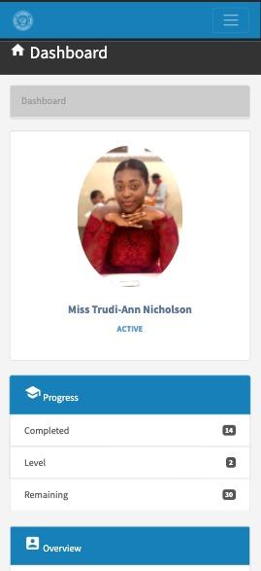

**Image 5: The responsive student’s dashboard on an iPhone X form factor**

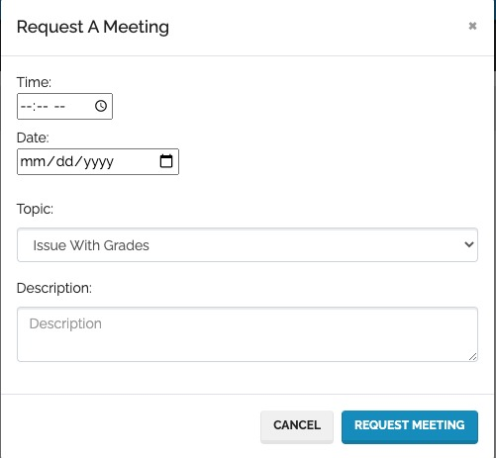

**Image 6: The student’s form to request a meeting with their advisor**

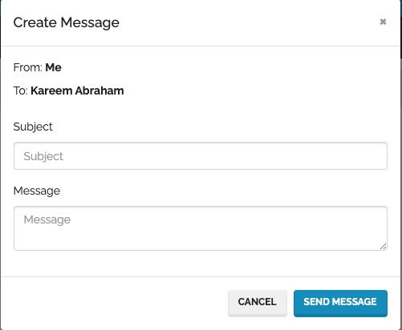

**Image 7: The student’s form to send a message to their advisor**

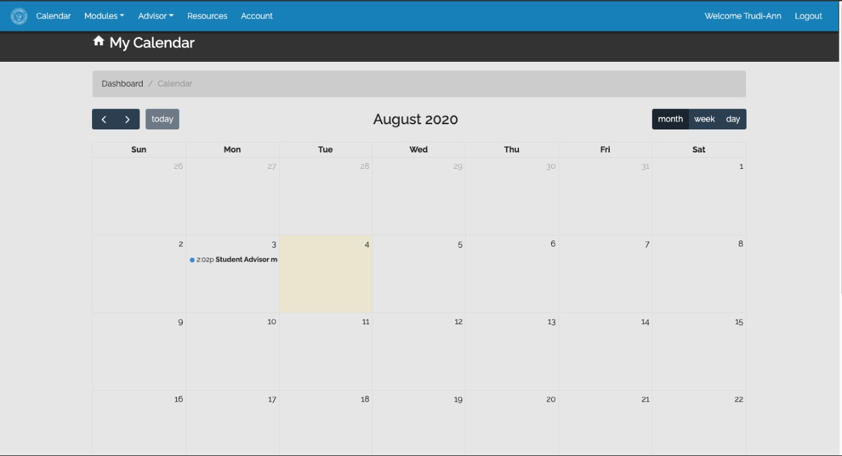

**Image 8: The student’s calendar to track dates of upcoming meetings**

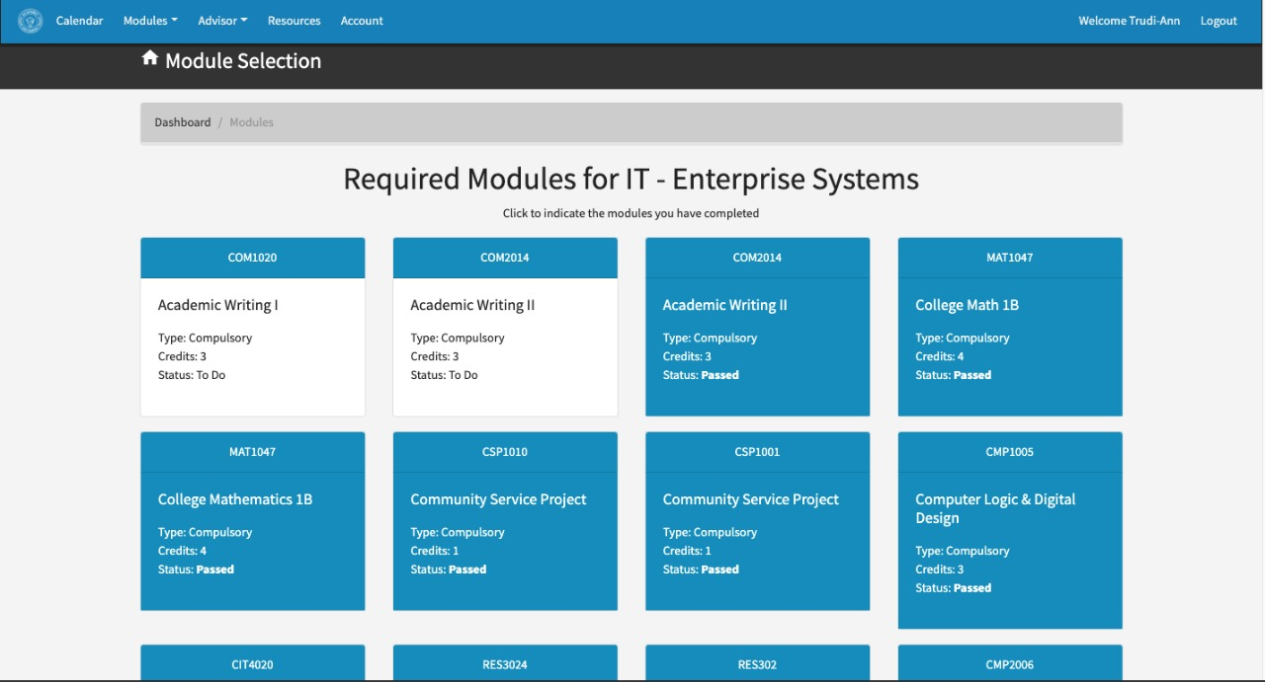

**Image 9: The section for students to track the modules they have completed**

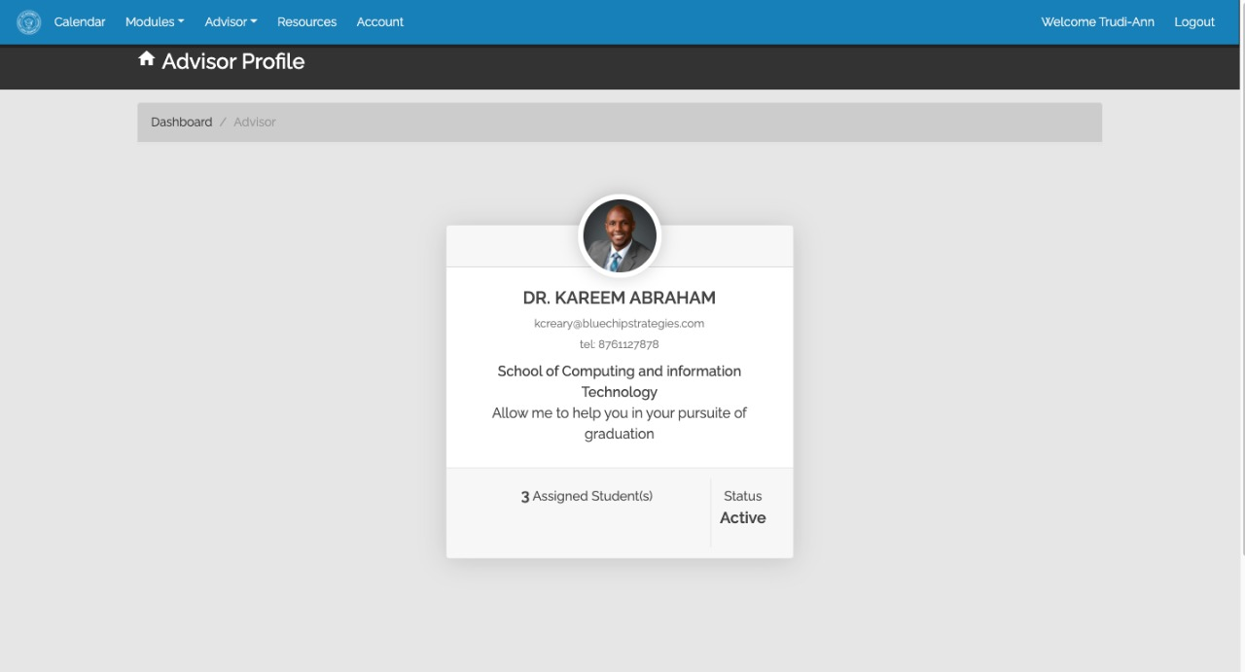

**Image 10: The students’ view of an advisor’s profile**

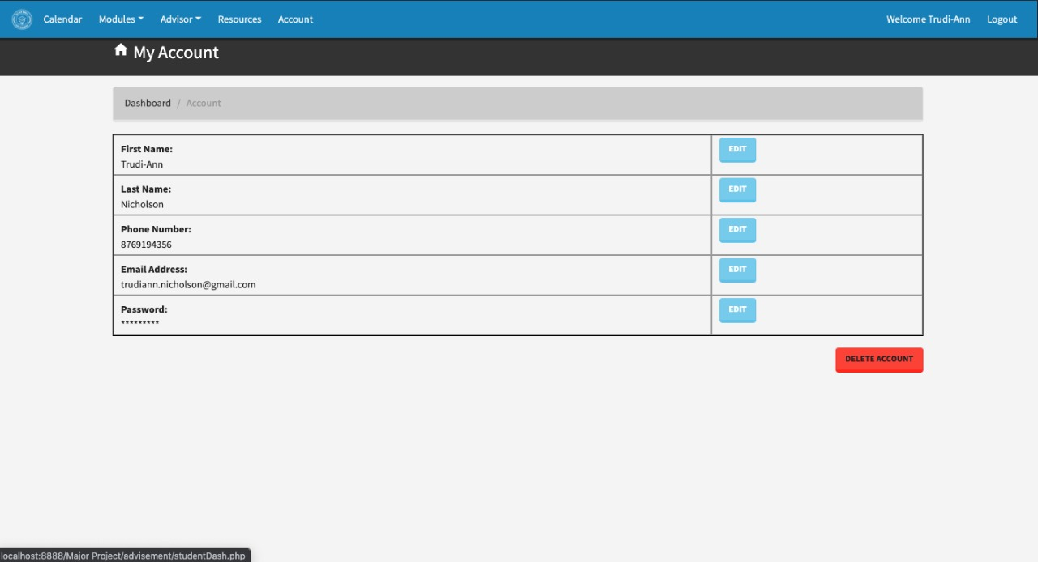

**Imabe 11: The student’s account page which allows editing of their profile**

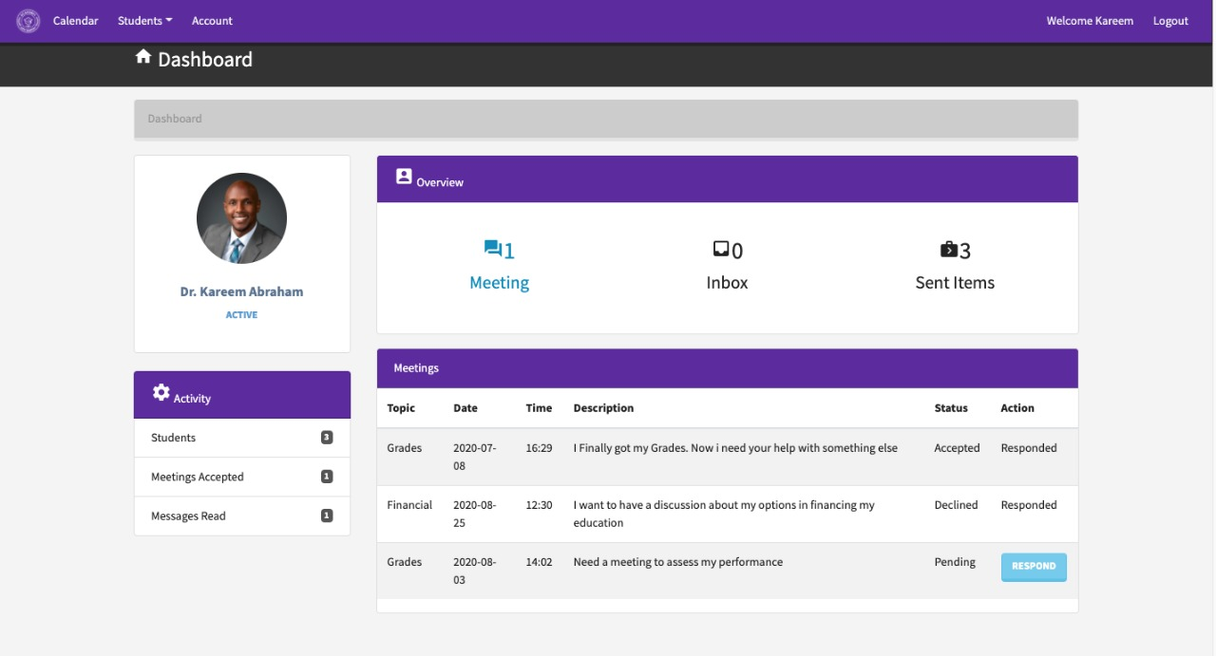

**Image 12: The advisor’s dashboard**

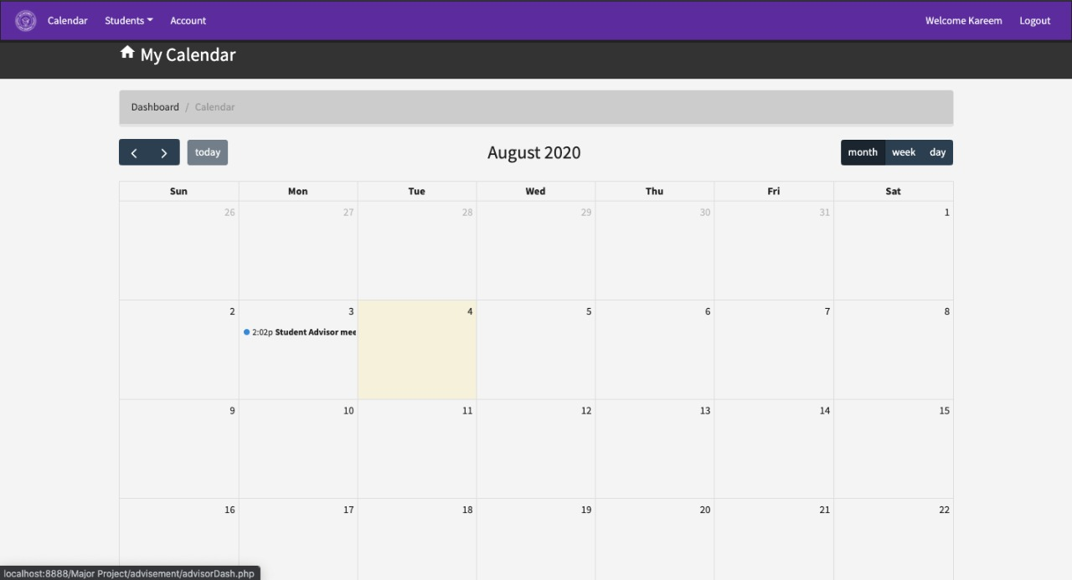

**Image 13: The student’s calendar to track dates of upcoming meetings**

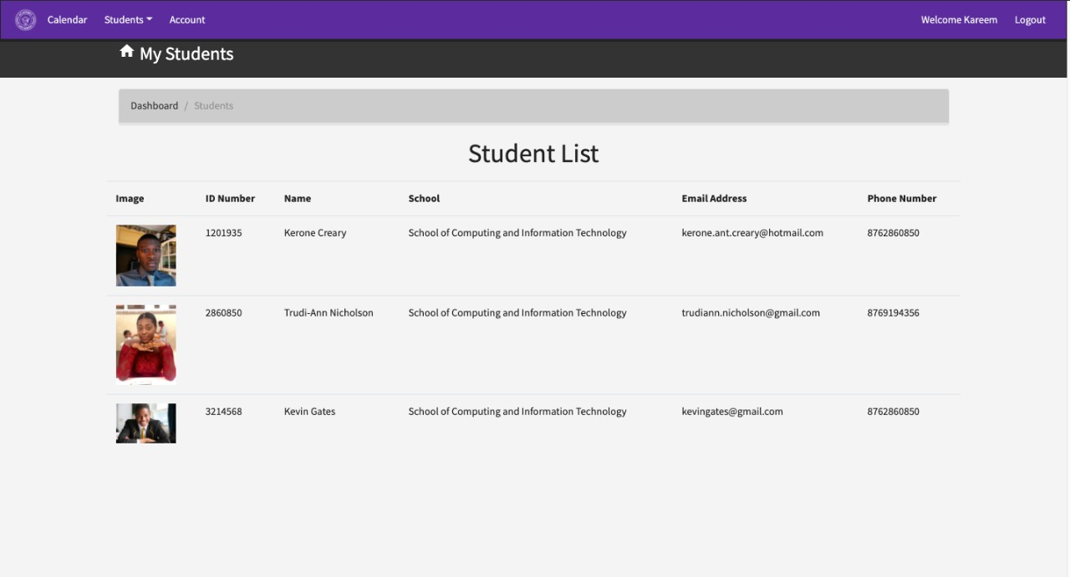

**Image 14: The page that shows all the students currently assigned to an advisor**

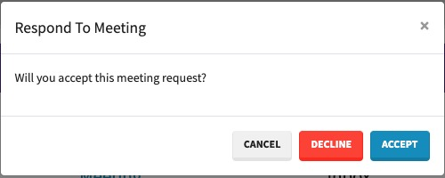

**Image 15: The advisor’s dialog box to respond to meeting requests from students**

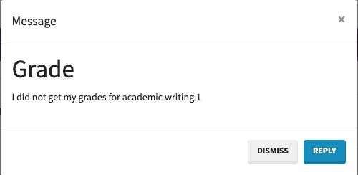

**Image 16: The advisor’s dialog box to reply to messages from students**

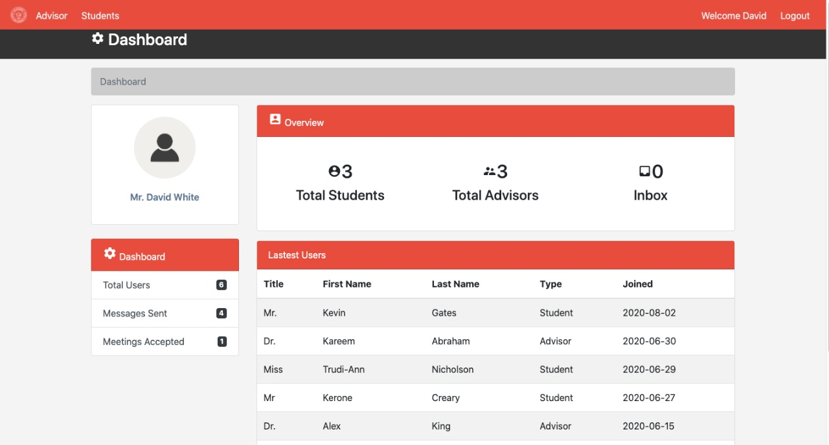

**Image 17: The administrator’s dashboard**

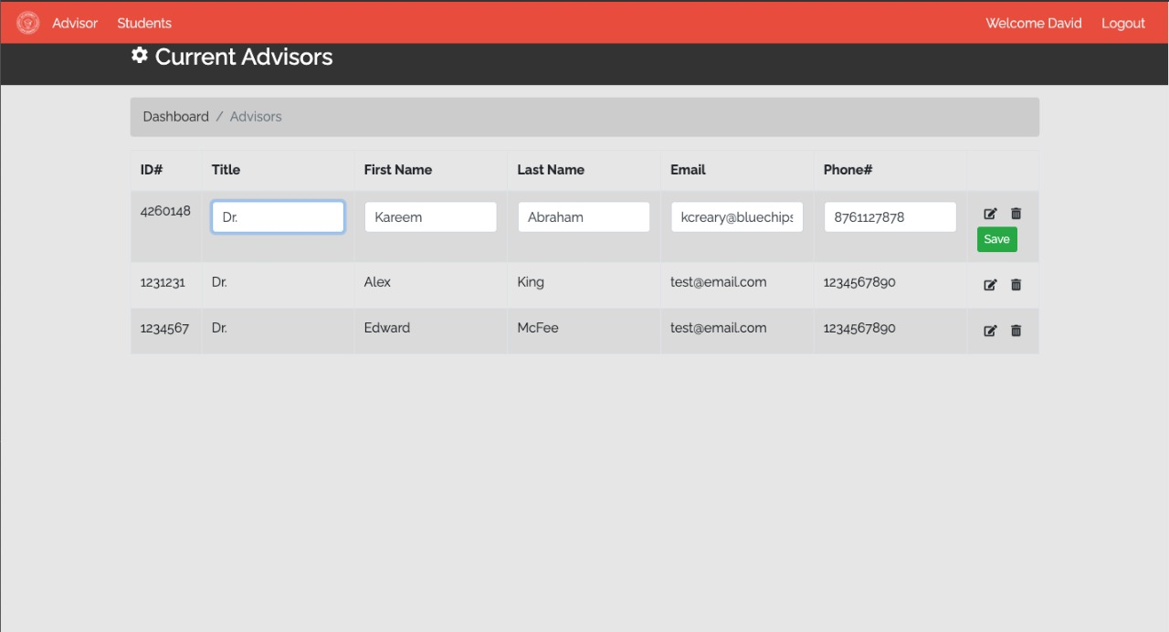

**Image 18: The page where the administrator performs CRUD operations**

**References**

AbdulWahhab, R., & Abdul Wahhab, S. (2016). Improving Academic Advising System by Using iAMA. Journal of Teaching and Education, 5(01), 191-208.

Afify, E., & Nasr, M. (2017). A Proposed Model for a Web-Based Academic Advising System. International Journal of Advanced Networking and Applications, 9(2), 3345-3361.

Ahmed, Z. A., & Ghareb, M. I. An Online Course Selection System: A Proposed System For Higher Education In Kurdistan Region Government. Retrieved from https://www.ijstr.org/final-print/aug2018/An-Online-Course-Selection-System-A-Proposed-System-For-Higher-Education-In-Kurdistan-Region-Government-.pdf

Andualem, G. College of Computing And Informatics Department of Computer Science Knowledge Base System Project on Student Expert System. Retrieved from https://www.academia.edu/30713786/student_Advising_Expert_system.pdf

Appleby, D. “The Teaching-Advising Connection.” The Mentor: An Academic Advising Journal, April 1, 2007. [http://www.psu.edu/dus/mentor/appleby1.htm].

Artino, A. R., La Rochelle, J. S., Dezee, K. J., & Gehlbach, H. (2014). Developing questionnaires for educational research: AMEE Guide No. 87. Medical Teacher, 36(6), 463–474. https://doi.org/10.3109/0142159X.2014.889814

Barreiro, P., L., and Albandoz, J., P., (2001). Population and Sample. Sampling Techniques.

Management Mathematics for European Schools. Retrieved November 20, 2017, from http://optimierung.mathematik.uni-kl.de/mamaeusch/aktivitaeten/akt_vortraege/garcia_de_galdeano_paper_puerto.pdf

Bean, J. P. (2005). Nine Themes of College Student Retention. College Student Retention: Formula for Student Success, Greenwood Publishing Group. 215-243.

Chicago. Retrieved from https://papers.ssrn.com/sol3/papers.cfm?abstract_id=2788105

Chicago. Retrieved from https://pdfs.semanticscholar.org/7b37/191c0c51ea45da836278fb6a64b01ade2b14.pdf

Chun Ho, C. , Lee, H. L. , Lo,W. K. , Lui, K. F. A. (2018),"Developing a Chatbot for College Student Programme Advisement," 2018 International Symposium on Educational Technology (ISET)(p. 52-56_. Retrieved from https://ieeexplore-ieee-org.ezproxy.utech.edu.jm/stamp/stamp.jsp?tp=&arnumber=8456189

Creswell, J. W. (2007). Research Design: Qualitative, Quantitative and Mixed Method Aproaches. SAGE Publications, 203–223. https://doi.org/10.4135/9781849208956

Creswell, J. W. (2013). Research design : qualitative, quantitative, and mixed methods approaches. Retrieved from http://www.worldcat.org/title/research-design-qualitative-quantitative-and-mixed-methods-appro

aches/oclc/918559456

Cuseo, J. “Academic Advisement and Student Retention: Empirical Connections and Systematic Interventions.” NACADA Clearinghouse of Academic Advising Resources web site, April 23, 2007. [http://www.nacada.ksu.edu/Clearinghouse/AdvisingIssues/Retention.htm]

Daramola, O., Emebo, O., Afolabi, I. T., & Ayo, C. K. (2014). Implementation of an intelligent course advisory expert system. IJARAI) International Journal of Advanced Research in Artificial Intelligence, 5(4). Retrieved from http://eprints.covenantuniversity.edu.ng/5611/#.XiEcGy2ZN24

Daramola, Olawande & Emebo, Onyeka & Ibukun, Afolabi & Ayo, Charles. (2014). Implementation of an Intelligent Course Advisory Expert System. International Journal of Advanced Research in Artificial Intelligence. 3. 10.14569/IJARAI.2014.030502.

Drake, J. K. (2011). The role of academic advising in student retention and persistence. About Campus, 16(3), 8-12. Retrieved from https://journals.sagepub.com/doi/abs/10.1002/abc.20062?journalCode=acaa

Frost, S.H. “Academic Advising for Student Success: A System of Shared Responsibility,” ASHE-ERIC Higher Education Report no. 3, Washington, D.C., George Washington University, School of Education and Human Development, 1991.

Gehlbach H, Brinkworth ME. 2011. Measure twice, cut down error: A process for enhancing the validity of survey scales. Rev Gen Psychol 15:380–387.

Hammer, M. & Champy, J. (1993) Reengineering the Corporation: A Manifesto for Business Revolution. Harper Collins, New York. Retrieved from http://advising.arizona.edu/sites/default/files/jaynearticle%20%283%29.pdf

Henderson, L. K., & Goodridge, W. (2015). AdviseMe: an intelligent web-based application for academic advising. International Journal of Advanced Computer Science and Applications, 6(8), 233-243.Retrieved from http://citeseerx.ist.psu.edu/viewdoc/download?doi=10.1.1.695.7675&rep=rep1&type=pdf

http://www.nacada.ksu.edu/Resources/Academic-Advising-Today/View-Articles/Paperless-Advising-for-Todays-Students.aspx

Kacalak, W., & Majewski, M. (2012). New intelligent interactive automated systems for design of machine elements and assemblies. In International Conference on Neural Information Processing (pp. 115-122). Springer, Berlin, Heidelberg. Retrieved from https://link.springer.com/chapter/10.1007/978-3-642-34478-7_15

Ke Chen, Han Lei, Ge Li, Wei Huang, Lihong Mu, Cash incentives improve participation rate in a face-to-face survey: an intervention study, In Journal of Clinical Epidemiology, Volume 68, Issue 2, 2015, Pages 228-233, ISSN 0895-4356, https://doi.org/10.1016/j.jclinepi.2014.08.002.

(http://www.sciencedirect.com/science/article/pii/S089543561400328X)

Martínez-Argüelles, M., Ruiz-Dotras, E., & Rimbau-Gilabert, E. (2010). The Academic Advising System in a Virtual University. Retrieved from https://ui.adsabs.harvard.edu/abs/2010telq.conf..345M/abstract

McMillan, J. H., & Schumacher, S. (2014). Research in education: Evidence-based inquiry. Pearson Higher Ed.

Multari, R. J. (2004). Technology in higher education academic advisement. The Mentor: An Academic Advising Journal, 6. Retrieved from http://dus.psu.edu/mentor/old/articles/040107rm.htm

Nutt, C.L. “Academic Advising and Student Retention and Persistence.” NACADA Clearinghouse of Academic Advising Resources web site, Sept. 1, 2006. [http://www.nacada.ksu.edu/Clearinghouse/AdvisingIssues/Retention.htm]

Omankwu, O. C., & Nwagu, C. K. (2019) An Expert System for Advising Undergraduate Students. Retrieved from <https://www.ijser.org/researchpaper/An-Expert-System-for-Advising-Undergraduate-Students.pdf>

Steele, G. E. (2014). Intentional use of technology for academic advising. Retrieved from https://nacada.ksu.edu/Resources/Clearinghouse/View-Articles/Intentional-use-of-technology-for-academic-advising.aspx

Underwood, Z. W. (2013). Paperless Advising for Today’s Students. Retrieved from

UTECH Jamaica. (2019). Student Handbook 2019-2020 (p. 223). Retrieved from <http://www.utechjamaica.edu.jm/publications/studentHandbook/index.html>

# **Appendix A - Common Issues**

The common issues for this project were:

The Coronavirus pandemic, which caused a lot of delay within our project and as such several deadlines weren’t met.

The timeline to complete this project prevented the team members from implementing a more advanced automated Academic Advisement System.

The distribution of questionnaires had to be changed from hard copy to soft copy due to the coronavirus pandemic, resulting in fewer responses.

# **Appendix B - Project Team**

|  |  |
| --- | --- |
| Names | Task Completed |
| Oneca Forbes (1300285) | Introduction, Implementation of Application |
| Kerone Hudson (1501287) | Research Methodologies and Procedures, Implementation of Application |
| Kerone Creary (1201935) | Summary, Conclusions and Recommendations, Implementation of Application |
| Gregory King (15062950 | Findings, Implementation of Application |
| Raheem Smith (1501192) | Literature Review, Implementation of Application |